Exercise: concepts from chapter 7

Reading: Fundamentals of Structural Geology, Ch 7

1) In the following exercise we consider some of the physical quantities used in a study of particle dynamics (Figure 1) and review their relationships to one another. While particle dynamics is not employed directly to investigate problems in structural geology, the physical quantities introduced here (force, mass, velocity, acceleration, momentum) are used extensively. Furthermore, the relationships reviewed here underlie the equations of motion for continuum descriptions of rock deformation.

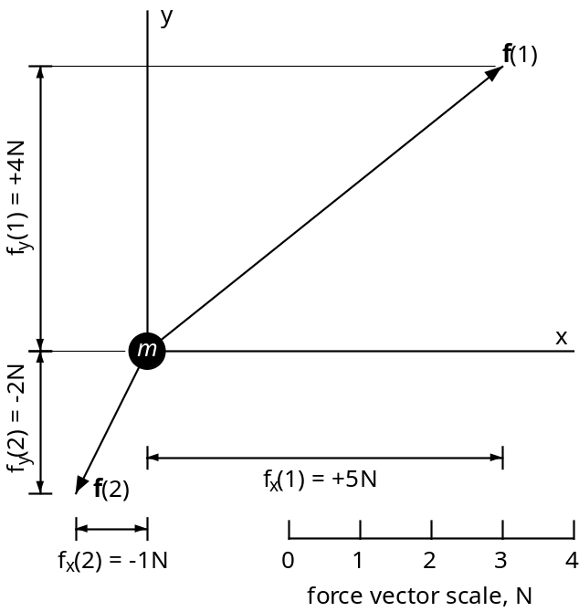
Figure 1. Schematic drawing of a point mass, m, acted upon by two forces. The particle has a mass of 2 kg and the two forces, f(1) and f(2), are constant in time for t > 0 and lie in the (x, y)-plane.

The two force vectors are written:
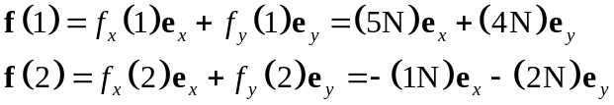
Use the vector scale in Figure 1 to verify the magnitudes of each component and confirm that the signs of these components are consistent with the direction of the vectors.

a) Calculate the two components (F_{x}, F_{y}) of the resultant force F acting on the particle and draw that vector properly scaled on Figure 1.

b) Calculate the magnitude, F, and direction, α(F), of the resultant force F. Here the angle α(F) is measured in the (x, y)-plane counterclockwise from Ox.

c) Calculate the two components (a_{x}, a_{y}), the magnitude, a, and the direction, α(a), of the acceleration, a, and draw that vector on Figure 1 with the appropriate scale. Compare the direction of the resultant force and the acceleration. By what factor do the magnitude and the acceleration differ?

d) The initial velocity is given as the two velocity components, v_{x}(0) and v_{y}(0):
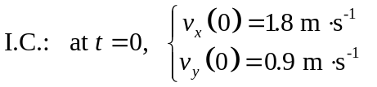
Calculate the magnitude, v₀, and direction, α(v₀), of the initial velocity vector.

e) Calculate the components [p_{x}(0), p_{y}(0)], the magnitude, p₀, and the direction, α(p₀) of the initial linear momentum of the particle. Compare the direction of the linear momentum to that of the acceleration and resultant force.

f) Calculate the instantaneous velocity components (v_{x}, v_{y}) and the magnitude, v, and direction, α(v), of the velocity at the time t = 5 s.

g) Calculate the instantaneous linear momentum components (p_{x}, p_{y}) and the magnitude, p, and direction, α(p), of the linear momentum at the time at t = 5 s.

h) Calculate the time derivatives of the components of linear momentum at t = 5 s. These are the respective components of the resultant force acting on the particle. Compare this resultant force to that applied at t = 0 s to show that you have come full circle back to the applied force.

2) For this exercise on rigid body dynamics and statics we consider a block of granite quarried from near Milford, Massachusetts, and placed on two parallel cylindrical rollers on a horizontal surface (Figure 2, next page). The average mass density of the granite is 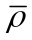 and the volume of the block is V. The Cartesian coordinate system is oriented with the z-axis vertical, the x-axis parallel to the cylindrical rollers, and the y-axis perpendicular to the rollers.

This image of the Milford granite is taken from the memoir by Robert Balk on Structural Behavior of Igneous Rocks (Balk, 1937). One might suppose that igneous rocks, having crystallized from magma, would be rather uninspiring to a structural geologist compared to sedimentary or metamorphic rocks in which contrasting layers highlight ornate structures such as folds and faults. However, because magmas often entrain chunks of host rock (zenoliths), and because minerals commonly crystallize from the melt before it stops flowing, so-called flow fabrics develop in which these heterogeneities have preferred orientations. The Milford granite exhibits both a foliation (planar fabric) and a lineation (linear fabric) composed of aligned dark minerals. The lineations trend parallel to TR and plunge about 30º SW, and the foliations strike ESE and dip about 35º SSW. Balk’s monograph is a thorough and insightful description of such fabrics, but does not address the physical behavior of flowing magma.

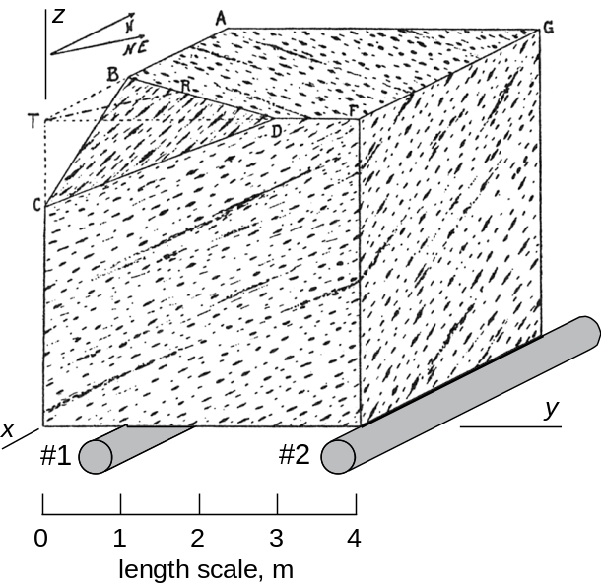
Figure 2. Schematic drawing of flow lines and flow layers in a quarried block of Milford granite (from Balk, 1937, Figure 8) sitting on two rollers (#1 and #2).

In this exercise we use the block of granite to review basic principals of the mechanics of rigid bodies. While the flowing magma that created the observed fabrics can not be treated as a rigid body, in its current state the granite block approximates such a body.

a) Write down the general vector equation for the linear momentum of the block of granite, P, as a function of the velocity of the center of mass, v*. Relate the time rate of change of the linear momentum to the resultant surface force, F(s), and body force, F(b), both acting at the center of mass, in order to define the law of conservation of linear momentum for this rigid body. Modify this relationship for the case where the granite block is at rest on the rollers. How would this change if the block were moving with a constant velocity in the y coordinate direction on the rollers?

b) Assume that the block of granite is at rest on the rollers and small enough to justify a uniform gravitational acceleration, g*, which is the only body force. Suppose the n discrete surface forces acting on the block are called f(j) where j varies from 1 to n. Write down the general vector equation expressing conservation of linear momentum for the static equilibrium of the block. Assume the rollers do not impart any horizontal forces to the block and expand this vector equation into three equations expressing static equilibrium in terms of the components of the external surface and body forces.

c) Construct a two dimensional free-body diagram through the center of mass (and center of gravity) of the granite block in a plane parallel to the (y, z)-plane in which the resultant body force is represented by the vector F(b), and the two surface forces due to rollers #1 and #2 are represented by f(1) and f(2), respectively. All of these forces are directed parallel to the z-axis. Place the origin of coordinates at the lower left corner of the block. The average density of the Milford granite is 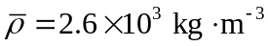, the acceleration of gravity component is 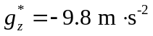, and the block is a cube 4 m on a side. Use the condition of static equilibrium for external forces to write an equation relating the magnitudes of the surface forces imparted to the block by rollers #1 and #2 to the magnitude of the gravitational body force. Can you deduce the individual magnitudes of the surface forces? Explain your reasoning.

d) Imagine removing roller #2 from beneath the granite block and explain qualitatively what would happen and why this would happen based on Figure 3. Use the law of conservation of angular momentum to write the general vector equation relating the angular momentum of the rigid body, Φ, to the resultant torques associated with the external surface and body forces. Rewrite this equation for the special case of static equilibrium (e.g. both rollers in the positions shown in Figure 2) under the action of discrete external surface forces, f(j), where j varies from 1 to n, and the resultant gravitational body force, 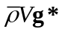, acting at the center of mass.

e) Use conservation of angular momentum to write an equation relating the magnitudes of the surface forces imparted to the granite block by rollers #1 and #2. From the symmetry of the problem depicted in Figure 3 it should be understood that all of the forces act in the (x, z)-plane parallel to the z-axis. Using this relationship and the other such relationship found in part c) solve for the magnitudes of the two surface forces imparted by the two rollers. Explain the difference between these two forces. How could you change the position of roller #2 such that the forces are equal? Given the configuration in Figure 2, what are the forces imparted by the rollers when roller #1 moves one meter to the right?

3) Much of our understanding of rock deformation in Earth’s crust comes from the consideration of models based on idealized solids and fluids. The theories of elastic solid mechanics and viscous fluid mechanics have been developed from quite different points of view with respect to the coordinate systems chosen to describe the positions of particles in motion. In this exercise we review these coordinate systems and the respective referential and spatial descriptions of motion.

a) Consider the kinematics of the opening of the igneous dike near Alhambra Rock, Utah (Figure 3). Using the outcrop photograph (provided electronically as a .jpg file), remove the dike and restore the siltstone blocks to their initial configuration. Draw a two-dimensional Lagrangian coordinate system on both the initial and the current state photographs. Illustrate the displacement, u, of a particle of siltstone on the dike contact using the two state description of motion such that:
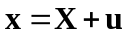
Here X is the initial position of the particle and x is the current position. Describe why this description of motion is referred to as ‘two state’. What might you learn about the intervening states from this description?

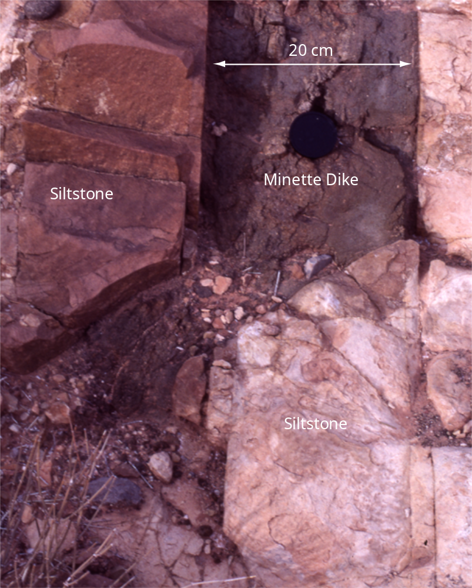
Figure 3. Outcrop of a Tertiary minette dike cutting the Pennsylvanian siltstone near Alhambra Rock, a few miles southeast of Mexican Hat, Utah (Delaney, Pollard, Ziony, and McKee, 1986).

b) A complete referential description of the particle motion near the dike would be given as:
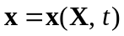
Here t is time which progresses continuously from the initial state (t = 0) to the current state. Indicate why this description is called ‘referential’. The particle velocity is given as:
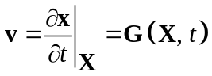
Explain why this is called the ‘material’ time derivative. Provide the general equation for calculating the acceleration, a, of an arbitrary particle given the function x(X, t) in . What property must this function have to carry out the calculation of the particle acceleration?

c) Consider the development of foliation and folds in the Dalradian quartzites and mica schists at Lock Leven, Scottish Highlands (Weiss and McIntyre, 1957). Suppose each sketch represents a snapshot in time t during the evolution of the foliation and folds. Draw the same two-dimensional Eulerian coordinate system adjacent to each of the four sketches and choose a particular location within these sketches defined by the same position vector x. Schematically draw the local velocity, v, of particles at x for stages b, c, and d using the spatial description of motion such that:
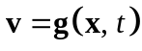
Indicate why this is referred to as a ‘spatial’ description of motion and in doing so explain why v in is referred to as the ‘local’ velocity.

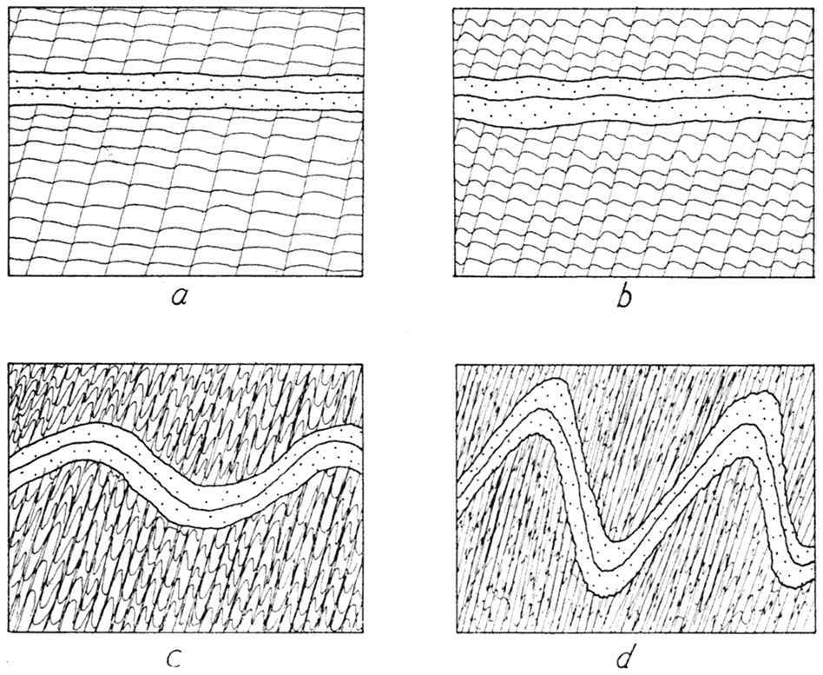
Figure 4. Drawings of the conceptualized stages in the development of foliation and folds in Dalradian quartzites (dotted pattern) and mica schists (foliated pattern) at Lock Leven, Scottish Highlands (Weiss and McIntyre, 1957).

d) For a complete spatial description of motion during folding the function g(x, t) in would describe the velocity at every position x for all times from t = 0 to t = current. Given such a function one could take the time derivative holding the current position constant:
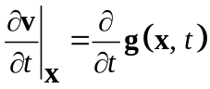
Explain why this is called the local rate of change of velocity and not the particle acceleration using the steady state example of the rising sphere (Fig. 5.12).

e) The particle acceleration, a, may be calculated, given the local velocity, v, defined in and a spatial description of motion, using the following equations:
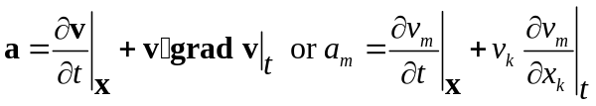
Here grad v is the gradient with respect to the spatial coordinates of the local velocity vector. Write out the component a₁ of the particle acceleration. Compare and contrast this definition of the particle acceleration with that defined using a referential description of motion:
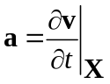

4) The construction of balanced cross sections is one of the most popular and touted methods employed in the oil and gas industry for the analysis of geological structures in sedimentary basins. This technique is a standard tool for the interpretation of seismic reflection data and the identification of hydrocarbon traps and migration pathways. The underlying assumptions used to balance cross sections are geometric and kinematic, that is they specify geometric quantities and displacements. For example, in one of the founding monographs on the subject, Balanced Geological Cross-Sections, one reads (Woodward, Boyer, and Suppe, 1989):
“Inherent in this technique are the assumptions that 1) deformation is plane strain, i.e. no movement into or out of the plane of the section; 2) area is conserved, implying no compaction or volume loss, for example by pressure solution of material; and 3) preservation of line length during deformation.”
Assumptions 2) and 3) ignore what we have learned from experiments conducted in rock mechanics laboratories since the middle of last century: rock does not deform in such a way that length, area, or volume are conserved. Instead, like other solids and fluids tested to characterize their mechanical behavior, rock deforms such that mass is conserved. In this exercise we explore the concept of mass conservation in order to understand what kinematic consequences follow from adopting this “law of nature”. It is, metaphorically speaking, putting the cart before the horse to make ad hoc geometric and kinematic assumptions that constrain mechanical behavior.

a) As an example of cross section balancing consider the Sprüsel fold from the Jura Mountains, Switzerland (Buxtorf, 1916). The fold profile (Figure 5) constructed by Buxtorf and enlarged by Laubscher (1977) is constrained largely by data from the Hauensteinbasis railroad tunnel because exposures at the surface are “inadequate”. Thus, considerable extrapolation is required to draw the shapes of the folded Mesozoic strata both above and below the tunnel. One way to constrain the extrapolation is to insist upon a balanced cross section.
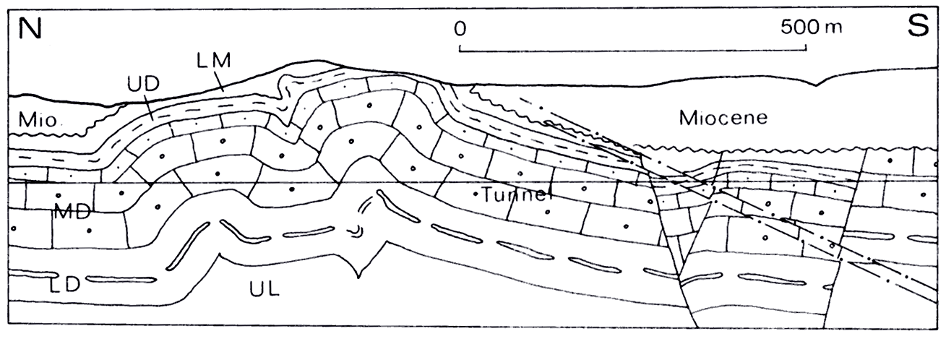
Figure 5. Cross section constructed by Buxtorf of the Sprüsel fold. Mesozoic strata include: LM = Lower Malm, UD = Upper Dogger, MD = Middle Dogger, LD = Lower Dogger, UL = Upper Lias.

To balance a cross section of the Sprüsel fold from the Jura Mountains, Switzerland, Laubscher assumed a kink fold geometry with straight limbs and sharp angular hinges. His geometric method is illustrated in Figure 6 where we see a fold, made up of two complementary kink bands, in the sedimentary strata terminating downward at a mobile layer resting on a detachment (décollement) at the top of a rigid basement. The strata and mobile layer are deformed by a uniform horizontal displacement along the left edge of the model, but neither the strata nor the mobile layer change thickness. The strata accommodate the deformation by kinking while the mobile layer accommodates the deformation by extruding material into the triangular void. Laubscher’s balanced cross section is shown in Figure 7.
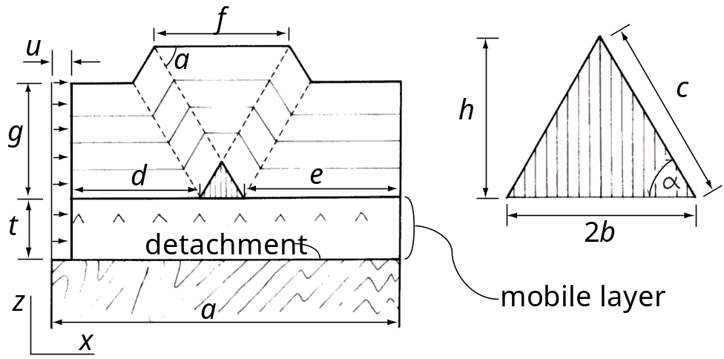
Figure 6. Geometric and kinematic model for a kink band style of folding with a mobile layer and a detachment (redrawn and annotated from Laubscher, 1976).

Use conservation of line length to relate the length of the kink fold limb, c, and dip of the kink band, α, to the horizontal displacement, u. Derive the equation for the area of the triangular void, A_{T}, as a function of the limb length, c, and dip, α. Use conservation of area to equate A_{T} to the area removed, A_{R}, from the mobile layer as is shortens without thickening. Combine your results to derive Laubscher’s equation for thickness, t, of the mobile layer:
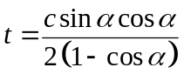
Derive an equation for the depth to the detachment from the upper surface of the fold created by the two complementary kink bands as a function of the width of this surface, f, the limb length, c, and dip, α.
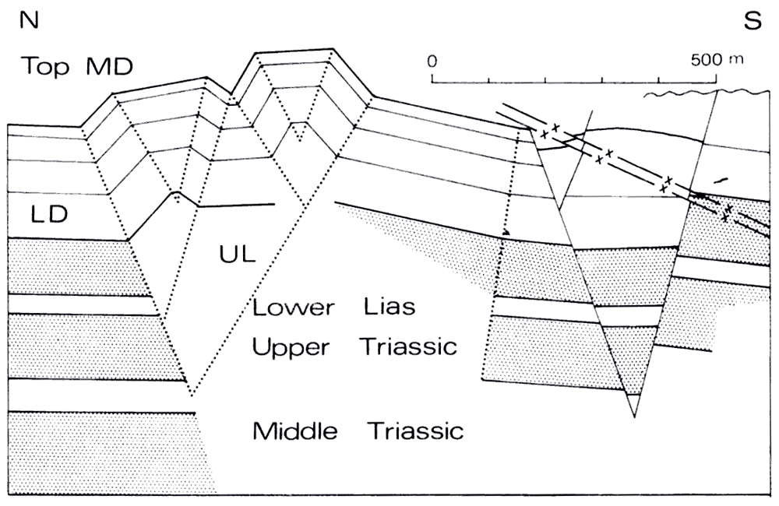
Figure 7. Balanced cross section of the Sprüsel fold (from Laubscher, 1977).

b) Now that the roles of conservation of line length and of area have been elucidated in the context of cross section balancing, consider the alternative: conservation of mass. Start with a volume element that is fixed in space at a location x in the evolving Sprüsel fold using a spatial description of motion. Sedimentary rocks pass through this volume element as they are folded. For the sake of a simple example suppose, at some moment in time, t, that the velocity at the center of this volume element is directed exactly upward in the positive z-coordinate direction, so v(x, t) = v_{z}e_{z}. The mass density of the rock also is a function of the current location and time, that is ρ = ρ(x, t). Derive the one-dimensional equation for the temporal rate of change of mass density, 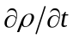, in terms of the mass flux per unit volume in the z-direction, ρv_{z}. Explain each step in your derivation starting with a word description of conservation of mass.

c) Expand the spatial derivative of the mass flux in your result from part b) assuming both density and velocity vary with z. Provide a physical interpretation for both terms of this expansion.

d) The equation derived in part b) is the one-dimensional form of the three-dimensional scalar equation of continuity:
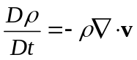
Show what is hidden on both sides of the equation of continuity as written in this form by expanding in terms of partial derivatives of density and of the velocity components.

e) A common postulate employed in modeling the flow of rock using viscous fluid mechanics is that the left side of is identically zero. In other words the mass density in the immediate surroundings of any particle does not change with time. With these constraints the rock is described as incompressible. Suppose the mobile layer under the Sprüsel fold (Figure 6) behaved as an incompressible material. What does this imply about the velocity gradients on the right-hand side of ? Describe a possible kinematics of the incompressible mobile layer.

f) Typically a plane strain condition is invoked for cross section balancing. Given this condition does the incompressible material behave in the same way as the material involved in balancing the cross section of the Sprüsel fold (Figure 6)? Consider separately the basement, the mobile layer, and the overlying folded strata. Laboratory tests demonstrate that rock is compressible. Qualitatively critique the assumed behavior of the model Sprüsel fold based upon this fact. Describe two common deformation mechanisms in rock that account for compressible behaviors.

5) Conservation of linear momentum is the second of three conservation laws that constitute the foundation of solid and fluid mechanics as developed in this chapter for the study of rock deformation. Here we investigate the consequences of this law for the temporal and spatial variation of velocity and for the spatial variation of stress in a deforming rock mass. In doing so we understand how conservation of linear momentum leads to the equations of motion. We take the example of the Sprüsel fold to emphasize that conservation of mass is necessary, but not sufficient to model the deformation there.

a) Consider a volume element that is fixed in space at location x in the evolving Sprüsel fold (Figure 5). Sedimentary rocks pass through this volume element as they are folded. In general, the momentum per unit volume, ρv(x, t), at the center of the element is a vector function of the current position and time. Momentum is carried in and out of the element in proportion to the velocity so the momentum flux per unit volume is v(ρv). Draw the volume element and schematically illustrate and label the z-component of momentum flux through each side. Derive an expression for the net rate of change of the z-component of momentum.

b) Generalize the expression found in part a) to three dimensions and write out the equation for the rate of change of momentum per unit volume, 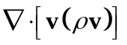, in component form. Describe how the subscripts on the velocity components conform to an ‘on-in’ subscript convention.

c) Conservation of linear momentum as describe in equation (7.84) includes a term for the resultant of all forces acting on the volume element. Draw the element and schematically illustrate and label all of the stress components and the gravitational body force components that contribute to the net force in the z-coordinate direction. Derive an expression of the net force in the z-coordinate direction.

d) Generalize the expression found in part c) to three dimensions and write out the equation for the resultant force per unit volume, 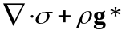, in component form.

e) The rate of increase of momentum per unit volume, 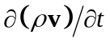, for the volume element is describe in the word equation (7.84). Use your results from the previous parts of this exercise to write down the z-component of this equation of motion. Write down the complete equation of motion in vector form.

6) Cauchy’s First and Second Laws of Motion (7.103 and 7.122) are independent of constitutive properties. In other words they apply to any material that can be idealized as a continuum. To address problems in structural geology these equations are specialized by invoking particular constitutive properties. In this exercise we consider the isotropic, isothermal, and linear elastic solid introduced by Robert Hooke which has the following constitutive relations giving the stress components, σ_{ij}, in terms of the infinitesimal strain components, ε_{ij}:
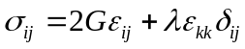
The shear modulus, G, and Lame’s constant, λ, are measures of the elastic stiffness and are related to the more familiar Young’s modulus, E, and Poisson’s ratio, ν, using:
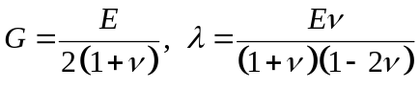
Laboratory tests provide estimates of these properties. For example, E would be the slope of the curves in Figure 8.

The referential description of motion is used, so the material coordinates, X, and time, t, are the independent variables. The kinematic quantities, velocity and acceleration, are linearized and the equations of motion are written using indicial notation as:
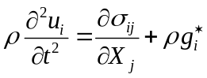
Usually the mass density, ρ, and the components of gravitational acceleration, 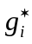, are taken from laboratory experiments. In this context one refers all deformation to the initial state and uses the displacement components, u_{i}, as the kinematic variables.

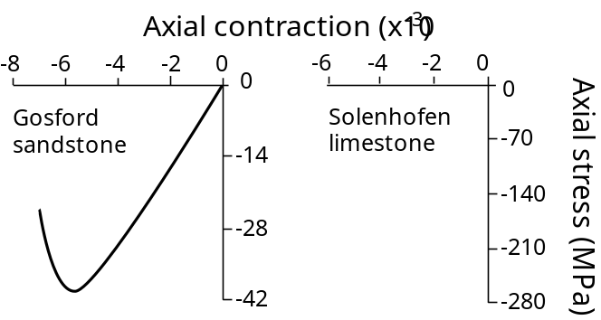
Figure 8. Laboratory data for two sedimentary rocks. The nearly linear initial portion of the stress – strain curve is characteristic of elastic behavior.

a) The three equations of motion and the six constitutive equations are not sufficient to solve problems in linear elasticity. The six kinematic equations relating the infinitesimal strain components to the displacement components are added to this set. Start with the equation using indicial notation for the Lagrangian finite strain components and the referential description of motion. Expand this equation for the components E_{zz} and E_{xz} and show how these are simplified to define the corresponding infinitesimal strain components. Write the six kinematic equations for the infinitesimal strain components as one equation using indicial notation. Identify the fifteen dependent variables corresponding to this set of fifteen equations.

b) Show how the equation of motion is simplified by replacing the stress components with the appropriate gradients in the displacement components to derive Navier’s equations of motion. Expand and use the third equation of motion in component form to illustrate the steps of the derivation.

c) In some applications the strain components are treated as the dependent variables given the stress components. Derive an alternate form of Hooke’s Law by solving for the strain components and using Young’s modulus, E, and Poisson’s ratio, ν, as the elastic constants from . Hint: these two elastic moduli may be used to relate the sum of the longitudinal strains and the sum of the normal stresses as follows:
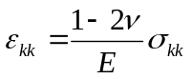

7) To address some problems in structural geology Cauchy’s First and Second Laws of Motion (7.103 and 7.122) are specialized by invoking the isotropic, isothermal, and linear viscous fluid introduced by George Stokes. This idealized material has the following constitutive relations giving the stress components in terms of the rate of deformation components:
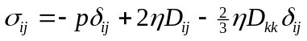
Values for the viscosity, η, are taken from laboratory experiments (Figure 9).

a) The six kinematic equations defining the rate of deformation components are required to write in terms of the velocity components. Write these six equations as one equation using indicial notation. Compare and contrast this kinematic equation with that relating the displacement components to the infinitesimal strain components.

b) Use the commonly employed constraint that flowing rock is incompressible to rewrite for the incompressible linear viscous material. Begin with a statement of conservation of mass.

c) Substitute your result from part b) for the stress components in Cauchy’s First Law of Motion (7.103) to derive the Navier-Stokes equations for the flow of an isotropic, isothermal, incompressible, linear viscous material with constant mass density.

d) Identify the four independent variables and the four dependent variables in the Navier-Stokes equations. What is the fourth equation needed to solve for the four dependent variables? Write it down using indicial notation.

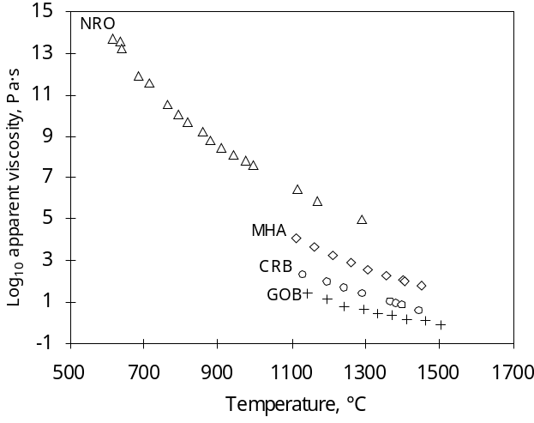
Figure 9. Laboratory data on viscosity as a function of temperature for four melts: NRO = obsidian, MHA = andesite, CRB and GOB = basalt.

