Exercise: dike and joint propagation at Willow Wash

Reading: Fundamentals of Structural Geology, Ch 9
Delaney et al., 1986, Field relations between dikes and joints: emplacement processes and paleostress analysis. J. Geophys. Res., v. 91, p. 4920-4938.

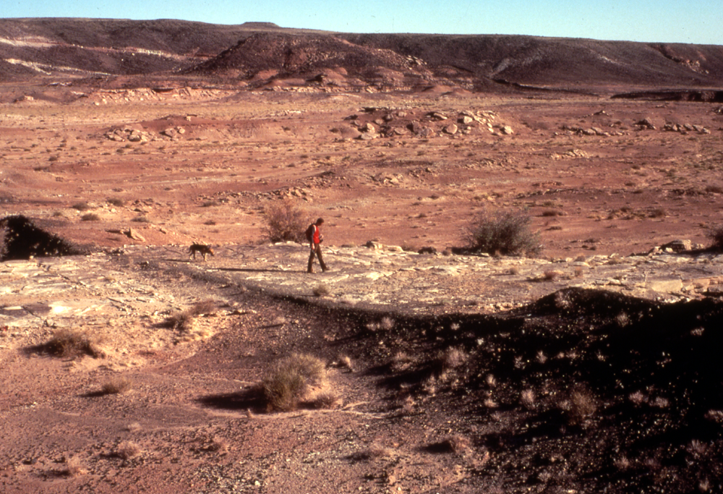
Figure 1. Paul Delaney and his faithful dog Pluto study a jointed sandstone outcrop cut by a diabase dike at Willow Wash, Utah. The narrow raised ridges of sandstone running parallel to the dike are the joint traces. See Figure 2 for a map of this outcrop.

This exercise involves the construction and evaluation of a model for the origin of joints in association with dikes. The field example is taken from the Colorado Plateau where Tertiary dikes intrude nearly horizontal sedimentary rocks. The spatial association of parallel dikes and joints led geologists to hypothesize that the magma invaded pre-existing fractures, thereby exploiting the inherent weakness of the sedimentary rock. Delaney et al., 1986 present field data and models that lead to a different hypothesis: the joints are created in the stress concentration associated with the tipline of a propagating dike.

1) Consider the formation of an igneous dike propagating vertically upward into the sedimentary basin. Let's say the dike is quite extensive vertically with little change in geometry or loading, so conditions are approximately those of plane strain in the horizontal plane. Suppose the state of stress in the horizontal plane before magma injection was:

Here the coordinate system is given with the y-axis directed due north. The strike of vertical joints is about 353º in this region (Fig. 2). Draw one of the joint surfaces with outward unit normal vector directed into the first quadrant. Calculate the normal and shear traction components acting on this surface. What is the least pressure of the magma in order for it to invade these joints?

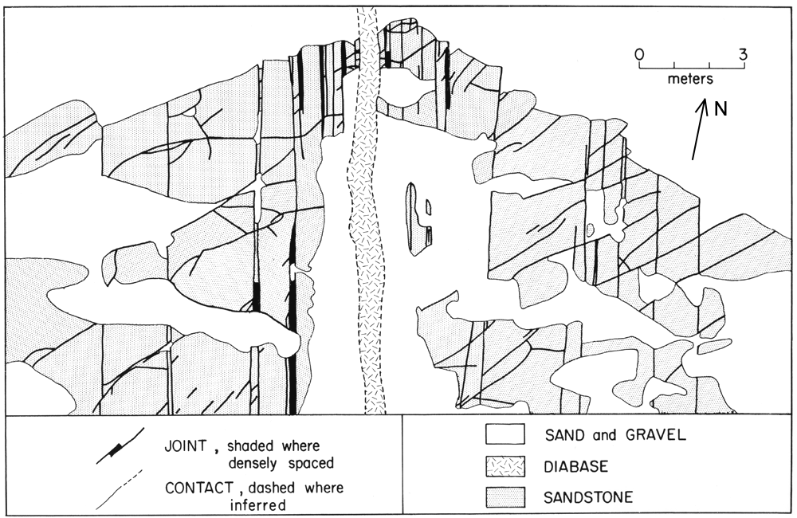
Figure 2. Map of portion of outcrop at Willow Wash (Delaney et al., 1986). All dike-parallel joints are shown and are within 9 m of dike contact. Note increase in spacing between joints with distance from the dike contact.

2) The specific conditions considered in 1) may be generalized for arbitrary states of stress having one principal axis perpendicular to Earth’s surface. Let the magnitudes of the vertical and two horizontal principal stresses be S_{V}, S_{H}, and S_{h}, respectively, and let the magma pressure be P. Postulate that the magma pressure must exceed the normal compressive stress acting across the putative dike plane for the dike to open and derive an equation relating the horizontal principal stresses, the magma pressure, and the orientation of the dike plane to define conditions under which the magma can open pre-existing joints. Prepare a graph that illustrates this relationship.

3) To model the stress distribution in the vicinity of the dike tip we use the approximations (9.72) for the near-tip stress field (Fig. 9.30) for a mode I crack from linear elastic fracture mechanics. Recall that ‘near’ the crack tip is a distance r < 0.01a where 2a is a characteristic length of the crack. Here the origin of coordinates is at the right hand tip of the crack with the x-axis extending away from the crack tip and parallel to the crack. The y-axis is perpendicular to the crack plane. For the pure mode I (opening) crack the stress components in the (x, y)-plane are approximated as:

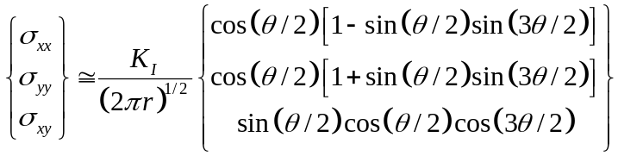

Here K_{I} is the mode I stress intensity which has a value that depends upon the fracture geometry and loading conditions. Stress intensity factors are tabulated in engineering handbooks (Tada et al., 1973). Normalize the three stress components and explore their distributions with angle θ about the crack tip, reproducing Fig. 9.31a. Use your result to explain the cluster of joints adjacent to the dikes at Willow Wash.

4) Note that all three stress components in go to zero as θ goes to –π or to +π. For the dike model what are the tractions acting on the dike contact? How do these tractions constrain the values of the stress components acting in the host rock at the contact? Is this consistent with ? If not, explain why these equations should or should not be used to model the state of stress near the dike tip. What are the implications of the isotropic state of stress for θ =0?

5) Use to calculate the principal stress magnitudes and directions in the (x, y)-plane as a function of θ about the crack tip. Re-evaluate your answer to 3) in light of this result.

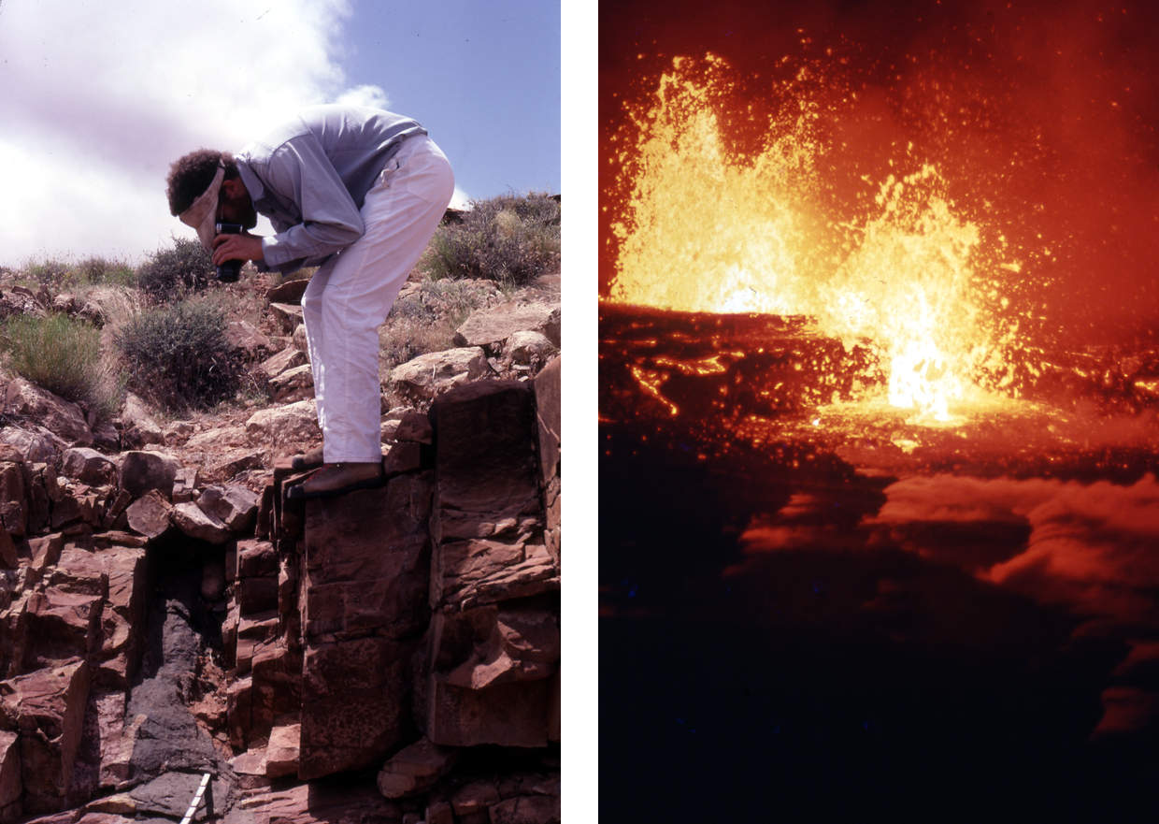
Figure 3. (left) Paul Delaney inspecting the joints clustered near a diabase dike. (right) Fissure eruption on Kilauea volcano, Hawaii. Note steam escaping from ground cracks ahead of the advancing dike. Could these be analogous to the joint set?

