Exercise solutions: concepts from chapter 3

1) The natural representation of a curve, c = c(s), satisfies the condition |dc/ds| = 1, where s is the natural parameter for the curve.
a) Describe in words and a sketch what this condition means.
b) Demonstrate that the following vector function (3.6) is the natural representation of the circular helix (Fig. 1) by showing that it satisfies the condition |dc/ds| = 1.
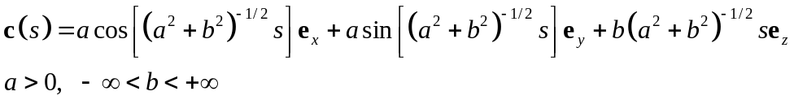
c) Use and Matlab to plot a 3D image of the circular helix (a = 1, b = 1/2π). An example is shown in Figure 1.

As illustrated in the sketch (Figure 1), c = c(s) is a vector function of a single real variable s and this parameter measures the arc length of the curve defined by the succession of vectors c(s) from an arbitrary initial point where s = 0.

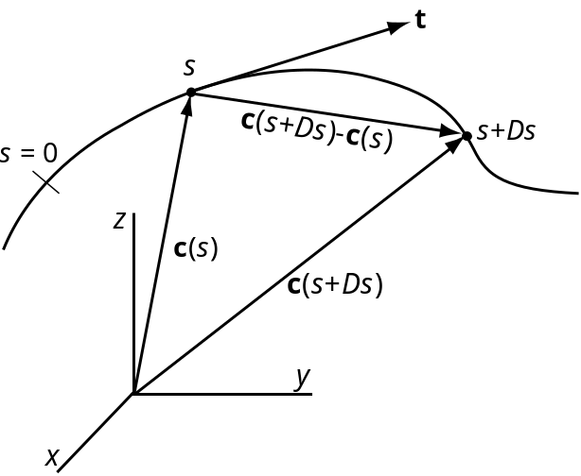
Figure 1. Sketch of natural representation of a curve c = c(s) with points s and s + Δs, tangent vector, t(s), and secant vector, c(s+Δs) - c(s).

The condition |dc/ds| = 1 is understood by considering the secant vector, c(s+Δs) - c(s), as illustrated above and the definition of the derivative:
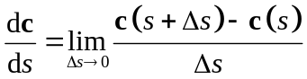
In this limit the secant vector becomes parallel to the tangent vector, t(s), to the curve at the point s, so the numerator in measures the arc length along the curve. However, the arc length is Δs, so the ratio in becomes equal to plus or minus one depending upon the sign of the numerator. Taking the absolute value of the ratio we find |dc/ds| = 1.

It is convenient to define the following constant with dimensions of length that includes the radius, a, and pitch, b, for the circular helix:
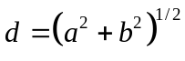
Making the substitution into the natural representation of the circular helix may be written:
Taking the first derivate of c with respect to s we find:
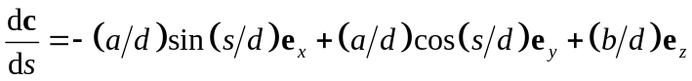
The absolute value of this derivative is the square root of the sum of the squared components of the vector such that:
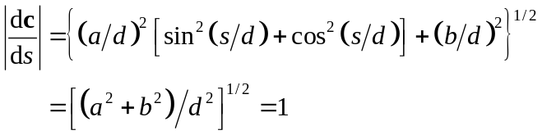
The last two steps follow from the Pythagorian relation 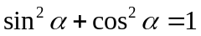 and the definition of d in .

The Matlab m-script helix_trihedron given below plots a 3D image of the circular helix (a = 1, b = 1/2π). The script also plots the moving trihedron at regular intervals on the helix. This is composed of the unit vectors (tangent, principal normal, binormal) which are derived in questions 2, 3, and 6 below.

% helix_trihedron.m
% plot the circular helix using equation (3.6)
% plot the moving trihedron using (3.11), (3.44), and (3.47)
clear all, clf % initialize memory and figure
a = 1; b = 1/(2*pi); % radius and pitch of helix
d = sqrt(a^2 + b^2); % common term for components
S = linspace(0,4*pi,100); % vector of natural parameter values
X = a*cos(S/d); % x-component of vector function for curve
Y = a*sin(S/d); % y-component
Z = (b/d)*S; % z-component
plot3(X,Y,Z,'k') % plot the helix
axis equal, grid on, box on, hold on
xlabel('x-axis'), ylabel('y-axis'), zlabel('z-axis')
% calculate points on helix for moving trihedron
S = linspace(0,4*pi,9); % vector of natural parameter values
X = a*cos(S/d); % x-component of vector function for curve
Y = a*sin(S/d); % y-component
Z = (b/d)*S; % z-component
TX = -(a/d)*sin(S/d); % x-component of tangent vector
TY = (a/d)*cos(S/d); % y-component
TZ = b/d; % z-component
quiver3(X,Y,Z,TX,TY,TZ,0.5,'r') % plot tangent vectors (green)
NX = -cos(S/d); % x-component of principal normal vector
NY = -sin(S/d); % y-component
NZ = 0; % z-component
quiver3(X,Y,Z,NX,NY,NZ,0.5,'g') % plot normal vectors (red)
BX = (b/d)*sin(S/d); % x-component of binormal vector
BY = -(b/d)*cos(S/d); % y-component
BZ = a/d; % z-component
quiver3(X,Y,Z,BX,BY,BZ,0.5,'b') % plot binormal vectors (blue)

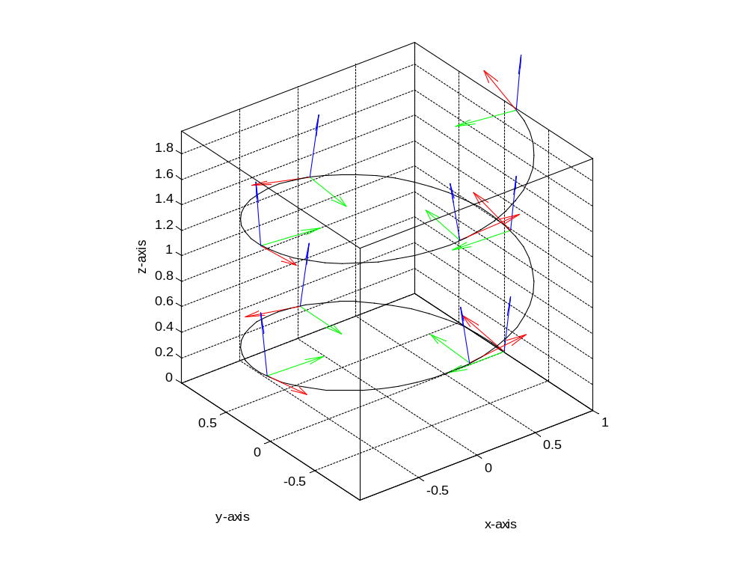
Figure 2. Plots of 3D image of the circular helix (a = 1, b = 1/2π). Unit tangent vectors (red), unit principal normal vectors (green), and unit binormal vectors (blue) are plotted are regular intervals on the helix.

2) An arbitrary representation of a curve, c = c(t), satisfies the condition |dc/dt| = ds/dt, where t is the arbitrary parameter and s is the natural parameter for the curve.
a) Demonstrate that the following vector function (3.2) is an arbitrary representation of the circular helix by showing that it satisfies this condition.
b) Show how this condition and the chain rule are used to derive the equation (3.8) for the unit tangent vector for an arbitrary representation of a curve and then use this equation to derive the unit tangent vector for the circular helix (3.11). In the process show how t and s are related.
c) Using your result from part b) for t(t) write the equation for the unit tangent vector, t(s), as a function of the natural parameter. Use this equation and Matlab to plot a 3D image of a set of unit tangent vectors on the circular helix (a = 1, b = 1/2π) as in Figure 1.

Taking the first derivative of with respect to the parameter t we have:
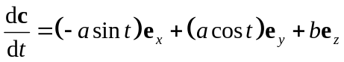
The absolute value of this derivative is:
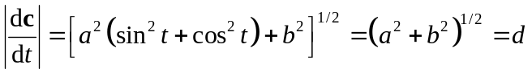
Comparing and , and using , the arbitrary and natural parameters are related as:
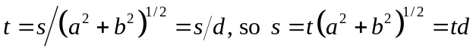
Note that t is dimensionless whereas s has dimensions of length. Taking the derivative of s with respect to t we have:
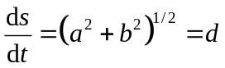
It follows from and that |dc/dt| = ds/dt.

The unit tangent vector is defined as t = dc/ds, but c = c(t) as in . Using the Chain Rule we write:
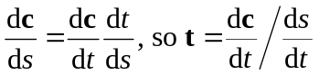
but,
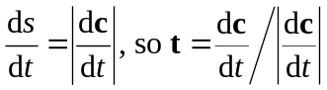
For the circular helix, using and substituting from and , the unit tangent vector in terms of the arbitrary parameter t is:
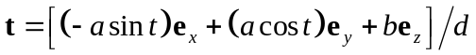
Substituting for t in using we have:
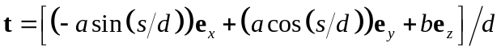
The Matlab m-script helix_trihedron.m given above plots a 3D image of the circular helix (a = 1, b = 1/2π) with the unit tangent vectors (red) at regular intervals (Figure 2).

3) The curvature vector, scalar curvature, and radius of curvature are three closely related quantities (Fig. 3.10) that help to describe a curved line in three-dimensional space.
a) Derive equations for the curvature vector, k(s), the scalar curvature, κ(s), and the radius of curvature, ρ(s), for the natural representation of the circular helix .
b) Show how these equations reduce to the special case of a circle.
c) Derive an equation for the unit principal normal vector, n(s), for the circular helix as given in .
d) Use Matlab to plot a 3D image (Fig. 1) of a set of unit principal normal vectors on the circular helix (a = 1, b = 1/2π).
e) Derive an equation for the unit binormal vector, b(s), for the circular helix . This is the third member of the moving trihedron.
f) Use Matlab to plot a 3D image (Fig. 1) of a set of unit binormal vectors on the circular helix (a = 1, b = 1/2π).

The natural representation of the circular helix is written using as:
The unit tangent vector is the first derivative of c with respect to s:
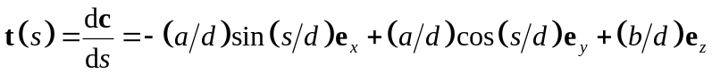
The curvature vector is the second derivative of c with respect to s:
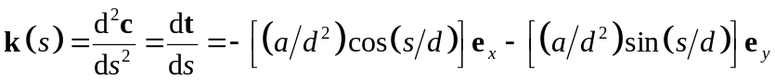
The scalar curvature is the magnitude of the curvature vector:
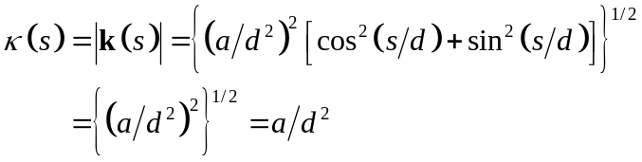
Using the scalar curvature for the circular helix is:
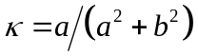
Note that the scalar curvature is a constant. The radius of curvature is the inverse of the scalar curvature:
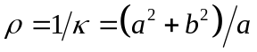
For the circle b = 0 and d = a, so the curvature vector from reduces to:
The scalar curvature and radius of curvature from and reduce to:
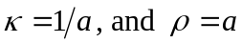
The unit principal normal vector is defined in (3.42) as:
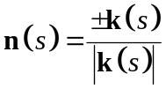
The choice of the sign in the numerator is arbitrary and is used to keep the vector pointing in a consistent direction along the curve. Using and for the circular helix and taking the positive sign we have:
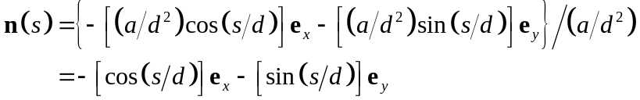
The Matlab m-script helix_trihedron.m given above plots a 3D image (Figure 2) of the circular helix (a = 1, b = 1/2π) with the unit principal normal vectors (green) at regular intervals.
From (3.45) the unit binormal vector is defined as:
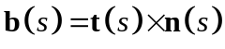
From (3.27) the vector (cross) product is given in terms of the respective components as:
Substituting for these components from and we have:
The Matlab m-script helix_trihedron.m given above plots a 3D image (Figure 2) of the circular helix (a = 1, b = 1/2π) with the unit binormal vectors (blue) at regular intervals.

4) If c = c(t) is the arbitrary parametric representation of a curve, then a general definition of the scalar curvature is given in (3.26) as:
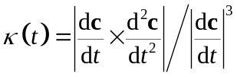
a) Show how this relationship may be specialized to plane curves lying in the (x, y)-plane where c(t) = c_{x}e_{x} + c_{y}e_{y} and the components are arbitrary functions of t.
b) Further specialize this relationship for the plane curve lying in the (x, y)-plane where the parameter is taken as x instead of t, so one may write c_{x} = x and c_{y} = f(x) such that c(x) = xe_{x} + f(x)e_{y} and the normal curvature is:
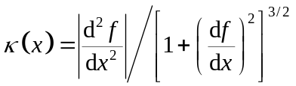
c) Evaluate the error introduced in the often-used approximation κ(x) ~ |d²f/dx²| by plotting the following ratio as a function of the slope, df/dx, in Matlab:
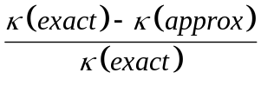
Develop a criterion to limit errors to less than 10% in practical applications.

For the required derivation it is helpful to write the derivatives in a more compact form using the prime notation. Given the arbitrary representation of a curve, c = c(t), the equation for the scalar curvature is written:
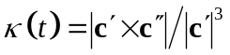
Given the plane curve c(t) = c_{x}(t)e_{x} + c_{y}(t)e_{y} the derivatives are expanded as:
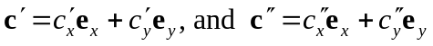
The vector (cross) product in the numerator of is found from the following determinant:
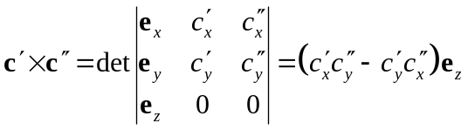
The magnitude of this vector is:
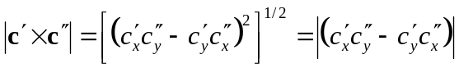
The denominator of is evaluated as:
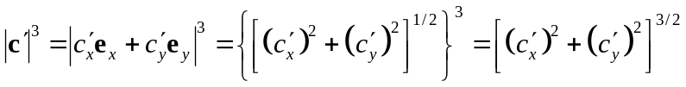
The scalar curvature is given by the ratio of the right hand sides of and :
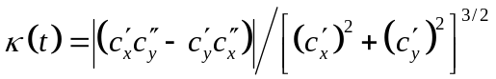
This is specialized for curves lying in the (x, y)-plane where the components and their derivative are arbitrary functions of t. If the parameter is taken as x instead of t, then we may write:
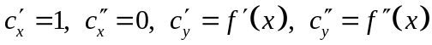
Substituting into and writing out the derivatives the scalar curvature is:
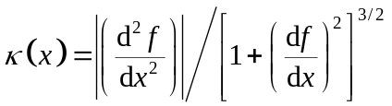
This is the form of the scalar curvature often introduced in elementary calculus courses. Using the prime notation for derivatives in , the exact and approximate scalar curvatures are written:
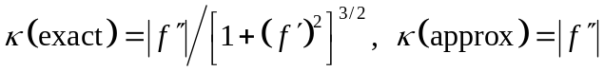
Note that the approximate scalar curvature is obtained by postulating:
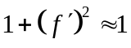
In other words the square of the first derivative of the function y = f(x) is small compared to one. Substituting into the error is written:
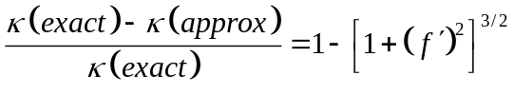
The slope of the curve y = f(x) is given by the first derivative f’(x) and the angle of the slope is (180/π)f’(x). The absolute value of this error is plotted versus the slope angle of the curve using the Matlab m-script curve_approx.m:

% curve_approx.m
% evaluation of error for plane curvature approximation
clear all, clf, hold on % initialize
S = linspace(0,pi/4,100); % slope values (radians)
E = abs(1 - ((1 + S.^2).^(3/2))); % absolute value of error
plot(S*180/pi,E*100) % plot in 2D
plot ([0 45], [10 10],'r--')
grid on, box on
xlabel('slope (degrees)'), ylabel('|error| (percent)')

From reading the graph in Figure 3, for slopes less than about 15 degrees, the absolute value of the error is less than about 10 percent. This error threshold is quantified using such that:
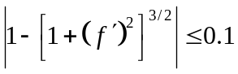
Rearranging:
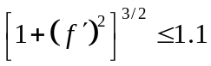
Solving for the magnitude of f’ we have:
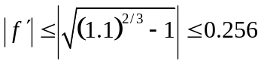
Recalling that f’ is the tangent of the slope of the curve, this threshold restricts the range of slope angles, θ, such that:
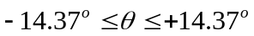

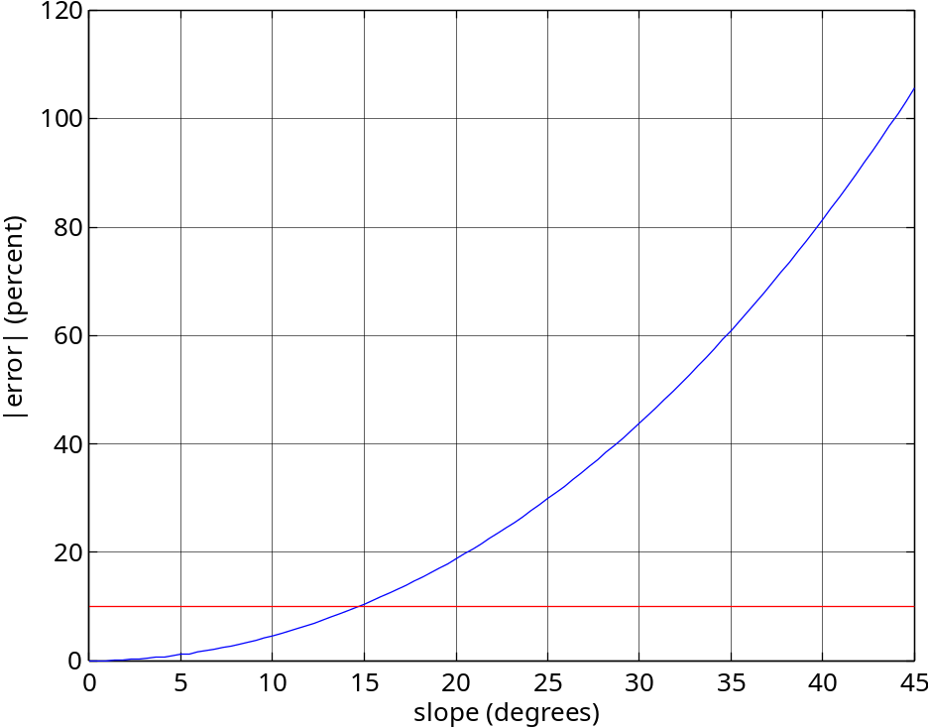
Figure 3. Plot of the absolute value of the error introduced in the approximation for the curvature is plotted versus the slope angle of the curve.

The approximation is reasonable for surfaces with slopes less than about 15 degrees but the error increases rapidly with slope reaching about 100% at 45 degrees.

5) If c = c(t) is the arbitrary parametric representation of a curve, then a general definition of the scalar torsion is given is (3.50) as:
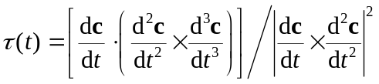
a) Derive an expression for the scalar torsion for the parametric representation of the circular helix of radius a and pitch b as given by:

The scalar torsion is written using the prime notation as:
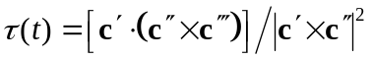
The derivatives in for the case of the circular helix are:
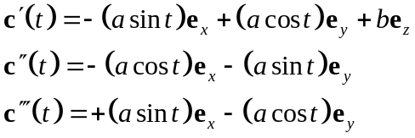
The numerator of is a triple scalar product which may be evaluated using (3.51):
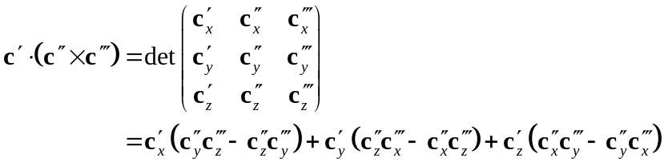
Of the three terms on the right side of only the last survives because 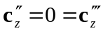as seen from the second and third of . The triple product for the helix evaluates to:
The vector product in the denominator of evaluates using the following determinant:
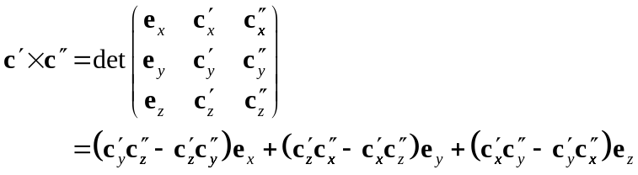
Noting from the second of that 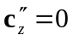 for the circular helix this vector product evaluates to:
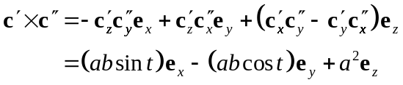
The square of the absolute value of is:
The ratio of and is the scalar torsion:
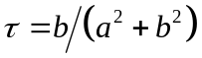
Note that the scalar torsion for the circular helix is a constant.

6) The two intrinsic scalar properties of continuous curves are the curvature (3.20) and the torsion (3.48). For the circular helix these properties are constants given by:
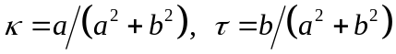
a) Use Matlab to plot two 3D graphs, one for the scalar curvature and the other for the torsion. Use a range for the radius, a, of 0 ≤ a ≤ 3 and for the pitch, b of –1.5 ≤ b ≤ +1.5. Study your graphs and describe the interesting features.

The Matlab m-script helix_cur_tor.m plots a 3D image of the scalar curvature, κ, and another for the scalar torsion, τ, using the ranges specified above.
% helix_cur_tor.m
% plot scalar curvature and torsion
clear all, clf % initialize
a = linspace(0,3,30); % vector of values for radius
b = linspace(-1.5,1.5,30); % vector of values for pitch
[A,B]=meshgrid(a,b); % grid of points
C = A./(A.^2 + B.^2); % scalar curvature
R=sqrt(A.^2 + B.^2);
C(find(R<0.20)) = nan; % exclude calculations very near (0, 0)
mesh(A,B,C) % plot surface as wire-frame
xlabel('Radius, a'), ylabel('Pitch, b'), zlabel('Scalar Curvature')
title('Curvature of Right Circular Helix')
axis equal, axis([0 3 -1.5 1.5 0 3])
T = B./(A.^2 + B.^2); % scalar torsion
T(find(R<0.20)) = nan; % exclude calculations very near (0, 0)
figure, mesh(A,B,T) % plot surface as wire-frame
xlabel('Radius, a'), ylabel('Pitch, b'), zlabel('Scalar Torsion')
title('Torsion of Right Circular Helix')
axis equal, axis([0 3 -1.5 1.5 -1.5 1.5])

From studying Figure 4 and recalling that for b = 0, κ = 1/a, there is a positive singularity in the scalar curvature as a → 0. Except in the neighborhood of this point κ → 0 as a → 0 and the helix degenerates into a straight line.

From studying Figure 5 and recalling that for a = 0, τ = 1/b, there is a positive and negative singularity in the scalar torsion as b → 0. For b = 0, τ = 0 except in the neighborhood of these singularities. For b << a, as a increases the torsion decreases toward zero with a sign given by the sign of b.

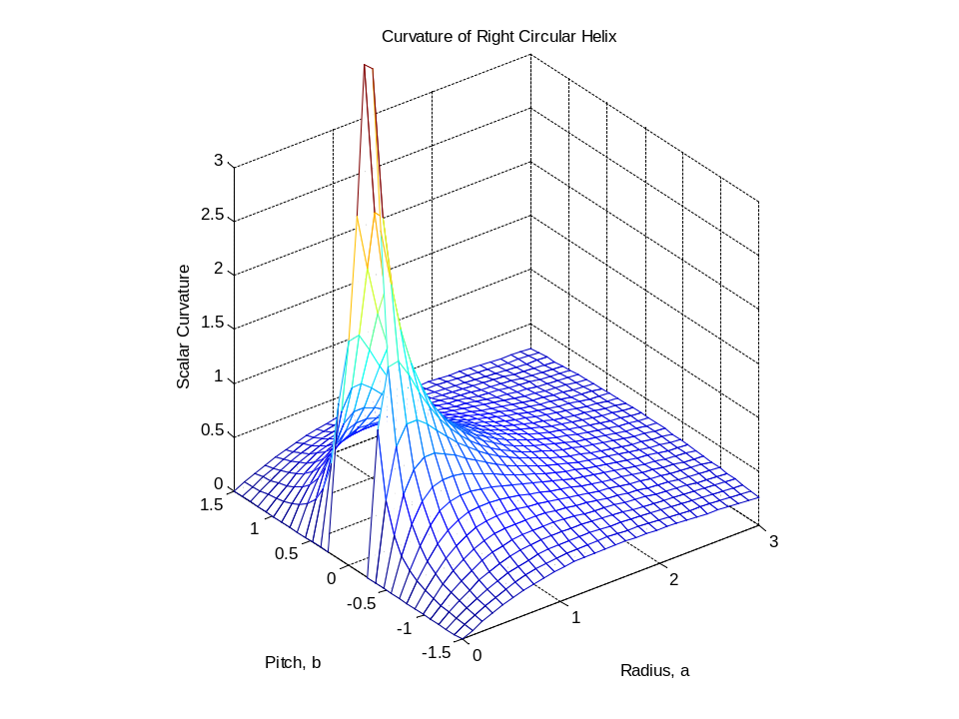
Figure 4. 3D plot of the scalar curvature using a range for the radius, a, of 0 ≤ a ≤ 3 and for the pitch, b of –1.5 ≤ b ≤ +1.5 for the circular helix.

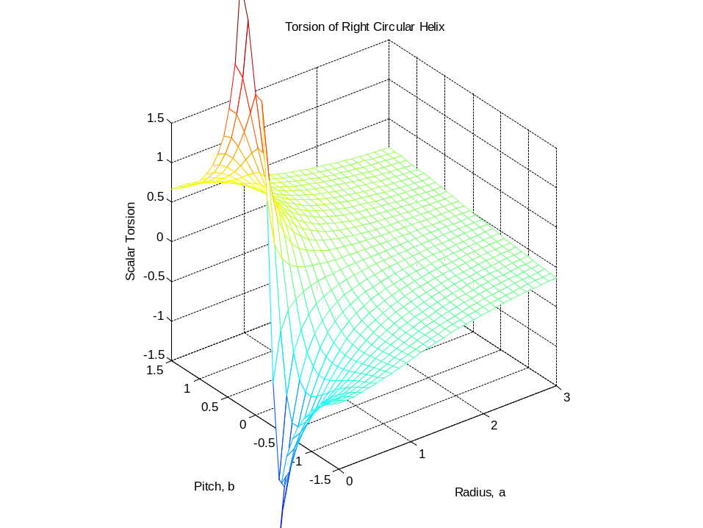
Figure 5. 3D plot of the scalar torsion using a range for the radius, a, of 0 ≤ a ≤ 3 and for the pitch, b of –1.5 ≤ b ≤ +1.5 for the circular helix.

7) The tangent plane at a point on a surface is illustrated in Figure 3.19. For geological surfaces it is the orientation of the tangent plane at a point on the surface that is measured using strike and dip. Given a general parametric representation of a surface s(u, v), where u and v are scalar quantities that are the parameters of the surface, the tangent plane to the surface is defined in (3.63) as:
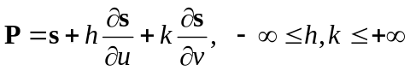
As an example consider the parametric representation of the sphere of radius a given using the two parameters, θ and φ:
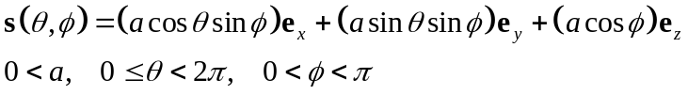
a) Derive the general equations for the tangent plane, P, to this sphere.
b) Evaluate your equation for the particular case of the point θ = π/2, φ = π/2 and explain how your result matches (or not) your intuition.
c) Use Matlab to plot the sphere and a portion of the tangent plane at the point θ = π/2, φ = π/2. Also, plot the tangent plane at the point θ = -π/4, φ = π/4.

For the sphere defined in the first partial derivatives of s(θ ,φ) are:
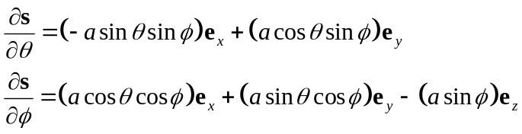
For the point θ = π/2, φ = π/2 the tangent plane is found by substituting these values into and and then inserting the resulting expressions into to find:
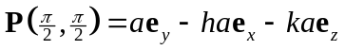
The first term on the right side locates the point at the intersection of the sphere and the positive y-axis. As h and k vary the second and third terms trace out a plane through this point that is parallel to the (x, z)-coordinate plane.

The Matlab m-script sphere_tangent_plane.m plots a 3D image of the unit sphere and the tangent plane according to . The second plot is obtained by changing the values of the parameters.

% sphere_tangent_plane.m
% plot the unit sphere as a wireframe 3D plot with a tangent plane
clear all; clf reset; % clear variables and figures
a = 1; m = 37; n = 19; % sphere radius, number of long. and lat. points
th = linspace(0,2*pi,m); % theta (long) coordinates on parameter plane
ph = linspace(0,pi,n); % phi (lat) coordinatess on parameter plane
[TH,PH]=meshgrid(th,ph); % grid of points on parameter plane
NX = a*cos(TH).*sin(PH); % x-component of radius vector
NY = a*sin(TH).*sin(PH); % y-component of radius vector
NZ = a*cos(PH); % z-component of radius vector
mesh(NX,NY,NZ) % 3D mesh surface plot of unit sphere
xlabel('x-axis'), ylabel('y-axis'), zlabel('z-axis')
title('The Unit Sphere with a Tangent Plane')
axis equal, hold on
tht = pi/2; pht = pi/2; % coordinates of point, s, for tangent plane
h = 0.5*a; k = 0.5*a;
H = [h,-h,-h,h,h,-h,h,-h]; K = [k,k,-k,-k,k,-k,-k,k];
sx = a*cos(tht)*sin(pht); % vector components for s
sy = a*sin(tht)*sin(pht);
sz = a*cos(pht);
dstx = -a*sin(tht)*sin(pht); % vector components of tangent vector
dsty = a*cos(tht)*sin(pht);
dspx = a*cos(tht)*cos(pht); % vector components of tangent vector
dspy = a*sin(tht)*cos(pht);
dspz = -a*sin(pht);
X = sx + H*dstx + K*dspx;
Y = sy + H*dsty + K*dspy;
Z = sz + K*dspz;
plot3(X,Y,Z,'k-') % plot a portion of the tangent plane

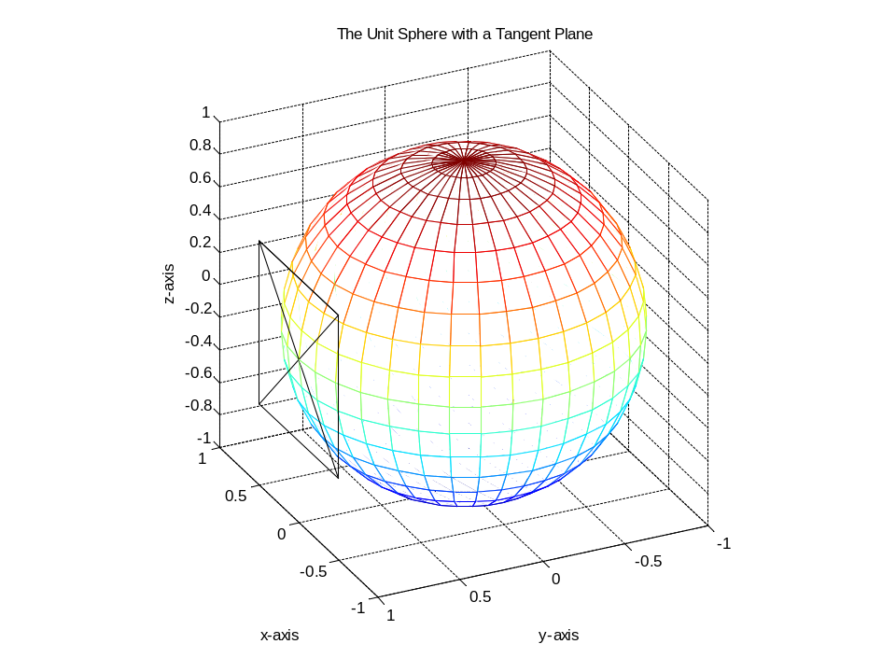
Figure 6. 3D image of the unit sphere with the tangent plane (black lines) for the point θ = π/2, φ = π/2.
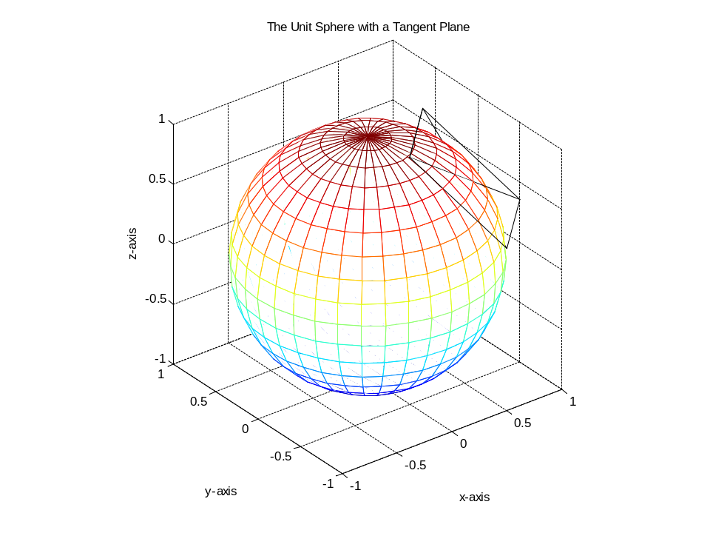
Figure 7. 3D image of the unit sphere and the tangent plane (black lines) for the point θ = -π/4, φ = π/4.

8) Given a general parametric representation of a surface s(u, v), where u and v are the parameters, the unit normal vector to the surface is defined in (3.73) as:
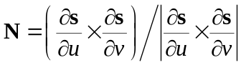
a) Derive the equation for the unit normal vector, N, for the sphere of radius a with the parametric representation:
b) Show that your equation for N obeys the condition N = -s/a, where s(θ, φ) is the position vector for a point on the sphere from an origin at the center of the sphere.

For the sphere of radius a defined in the first partial derivatives are:
The vector product of these derivatives is found from the general definition for two arbitrary vectors, u and w, as given in (3.27):
Substituting the components from into we find:
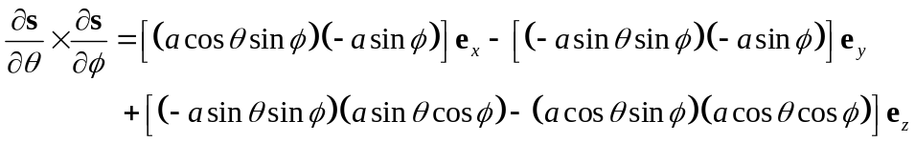
Combining terms:
The absolute value of the vector product is:
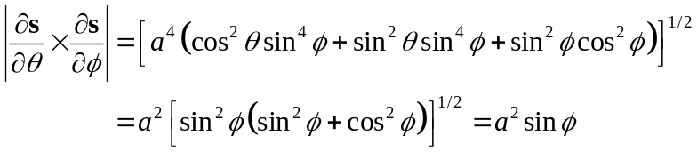
Taking the ratio of and we have the unit normal vector for the sphere:
The position vector for a point on the sphere is given in :
Comparing and we have N = -s/a.

c) Given orientation data from a field measurement of strike and dip (α_{s}, φ_{s}) of a bedding surface, show how these angles would be converted to the trend and plunge (α_{n}, φ_{n}) of the normal to that bed. Then show how these angles are used to compute the components of the unit normal vector for the bedding surface.

9) The coefficients of the first fundamental form are used to calculate arc lengths of curves. The coefficients of the first fundamental form are defined in (3.85) as:
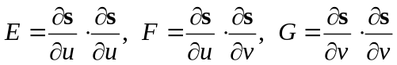
The arc length of a curve c[u(t), v(t)] on a surface, s(u,v) is defined in (3.89) as:
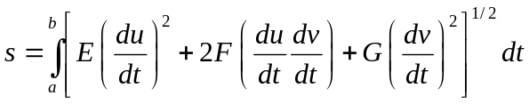
As an example consider the parametric representation of the elliptic paraboloid:
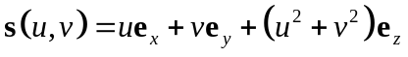
a) Consider the u-parameter curve c(u, 0.7) and calculate the arc length of this parabola from u = -1m to u = +1m.
b) Use Matlab to plot the elliptic paraboloid and the parabolic curve c(u, 0.7).

For the circular paraboloid defined in the coefficients are:
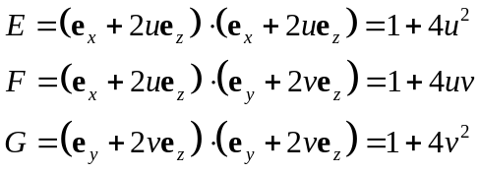
For a u-parameter curve u = t and v = constant, so du/dt = 1 and dv/dt = 0. In this case the limits of integration are a = -1m and b = +1m, and dt = du. Making these substitutions in we have:
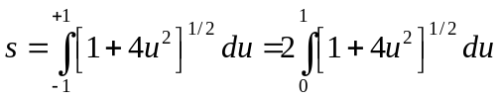
From Jeffrey, p. 158 (or similar table of integrals):
Here a = 1, c = 4, and x = u so:
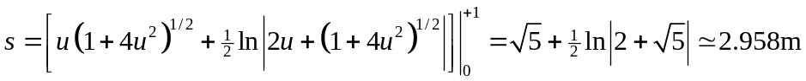

The Matlab m-script circ_paraboloid.m plots a 3D image of the circular paraboloid and the u-parameter curve c(u, 0.7).

% circ_paraboloid
u = linspace(-1,1,21); % vector of u-coords on parameter plane
v = linspace(-1,1,21); % vector of v-coords on parameter plane
[U,V]=meshgrid(u,v); % grid of points on parameter plane
SX = U; % x-component of vector function for surface, s=f(u,v)
SY = V; % y-component of s=f(u,v)
SZ = U.^2 + V.^2; % z-component of s=f(u,v)
surf(SX,SY,SZ) % surface plot: wire-frame with color fill
xlabel('x-axis'), ylabel('y-axis'), zlabel('z-axis')
title('surface plot: elliptic paraboloid'), axis equal
figure, plot(u,SZ(18,1:21)) %plot u-parameter curve c(u,0.7)
xlabel('x-axis'), ylabel('z-axis')
title('u-parameter curve on elliptic paraboloid, v = 0.7')
axis equal, axis([-1 1 0 2])

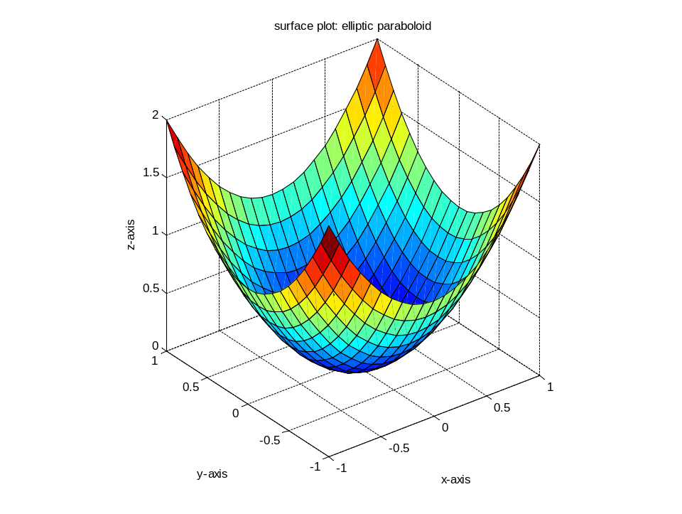
Figure 8. 3D image of the circular paraboloid.

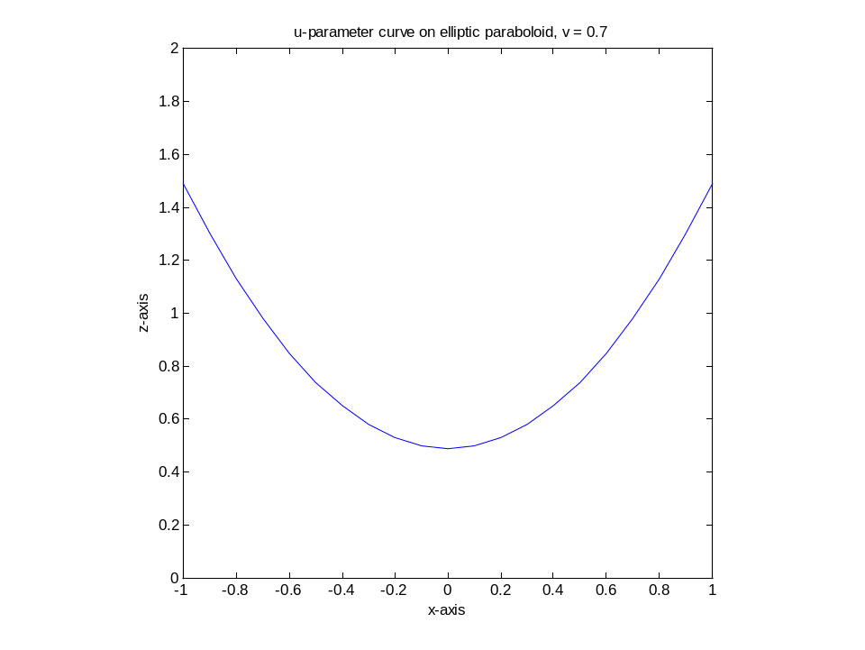
Figure 9. Plot of the u-parameter curve c(u, 0.7) to the circular paraboloid.

10) The coefficients of the first fundamental form may be used to calculate surface area (Fig. 3.26) given the parametric representation of a surface. The general equation for the surface area in terms of the parametric representation s(u,v) and the coefficients of the first fundamental form is given in (3.95) as:
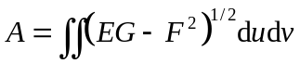
Consider the following representation of the sphere of radius a:
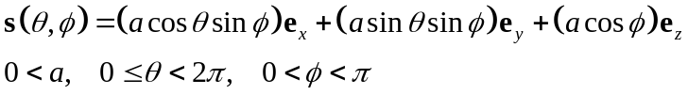
a) Derive an equation for the surface area of the sector of the sphere within the range 0 ≤ θ ≤ π/4 and 0 < φ ≤ π/6 and evaluate this for a = 1m.
b) Plot this sector of the sphere in 3D using Matlab.

For the sphere, s(θ, φ), defined in the surface area is calculated using such that:
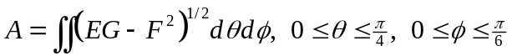
The coefficients of the first fundamental form are given in (3.85) as:
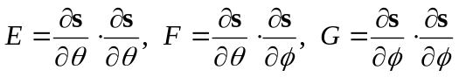
The first partial derivatives of s(θ, φ) are:
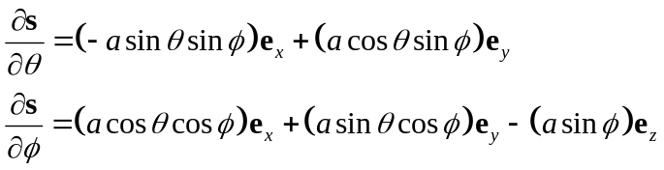
Uisng in the coefficients of the first fundamental form are:
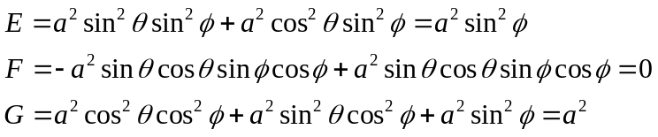
Therefore, the integrand of is:
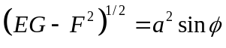
The integral is evaluated over the specified ranges as:
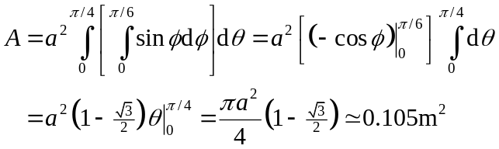
The Matlab m-script circ_paraboloid.m plots a 3D image of the sector of the sphere within the range 0 ≤ θ ≤ π/4 and 0 < φ ≤ π/6.

% sphere_sector.m
% plot a sector of the unit sphere
m = 10; n = 16; % number of longitude and latitude points
lm = linspace(0,pi/4,m); % long. coordinates on parameter plane
ph = linspace(0+eps,pi/6,n); % lat. coordinates on parameter plane
[LM,PH]=meshgrid(lm,ph); % grid of points on parameter plane
NX = cos(LM).*sin(PH); % x-component of radius vector
NY = sin(LM).*sin(PH); % y-component of radius vector
NZ = cos(PH); % z-component of radius vector
figure, mesh(NX,NY,NZ) % 3D mesh surface plot of unit sphere
xlabel('x-axis'), ylabel('y-axis'), zlabel('z-axis')
title('Sector of the Unit Sphere'), axis equal
axis([0 .5 0 .5 .8 1])

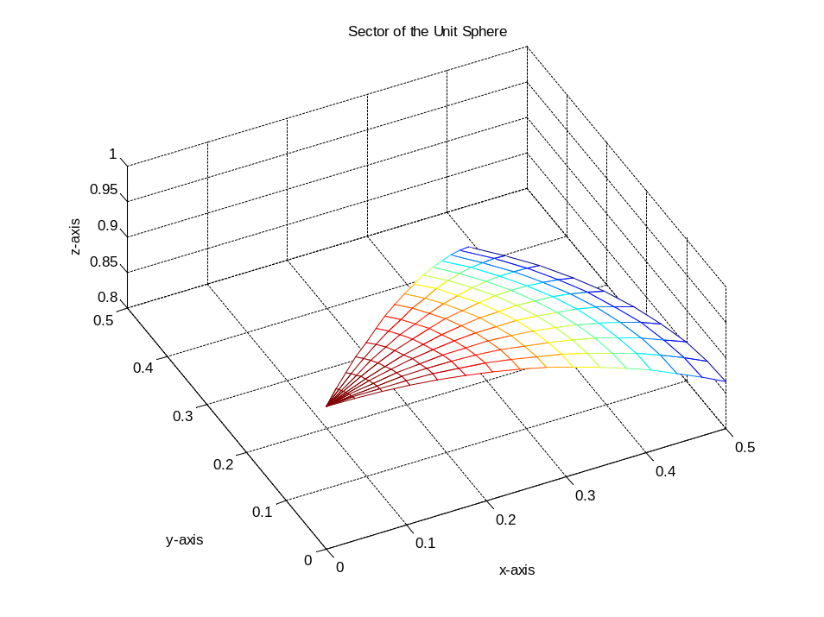
Figure 10. 3D image of the sector of the sphere within the range 0 ≤ θ ≤ π/4 and 0 < φ ≤ π/6.

11) The general equation for the unit normal vector to a surface with the parametric representation s(u,v) is given in (3.73) as:
As an example consider the surface with the parametric representation:
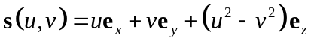
a) Use Matlab to plot a 3D illustration of this surface as a wire frame or other suitable graph and describe the shape. This is the hyperbolic paraboloid (Fig. 3.29c).
b) Derive an equation for the unit normal vector, Ν(u, v), of the hyperbolic paraboloid given in . Compare your equation to (3.75) which is the unit normal vector of the elliptic paraboloid and describe the differences.
c) Use Matlab to plot the unit normal vectors on the hyperbolic paraboloid.

The Matlab m-script hyperbolic_paraboloid.m plots a 3D image of the surface .

% hyperbolic_paraboloid.m
% plot hyperbolic paraboloid and normal vectors
u = linspace(-1,1,21); % vector of u-coords on parameter plane
v = linspace(-1,1,21); % vector of v-coords on parameter plane
[U,V]=meshgrid(u,v); % grid of points on parameter plane
SX = U; % x-component of vector function for surface, s=f(u,v)
SY = V; % y-component of s=f(u,v)
SZ = U.^2 - V.^2; % z-component of s=f(u,v)
surf(SX,SY,SZ) % surface plot: wire-frame with color fill
xlabel('x-axis'), ylabel('y-axis'), zlabel('z-axis')
title('surface plot: hyperbolic paraboloid'), axis equal
D = sqrt(1+4*U.^2+4*V.^2); % calculate unit normal vector
NX = -2*U./D; NY = 2*V./D; NZ = 1./D;
figure, mesh(SX,SY,SZ) % mesh plot: wire-frame
xlabel('x-axis'), ylabel('y-axis'), zlabel('z-axis')
title('hyperbolic paraboloid with normals'), axis equal, hold on
quiver3(SX,SY,SZ,NX,NY,NZ) % plot unit normal vectors

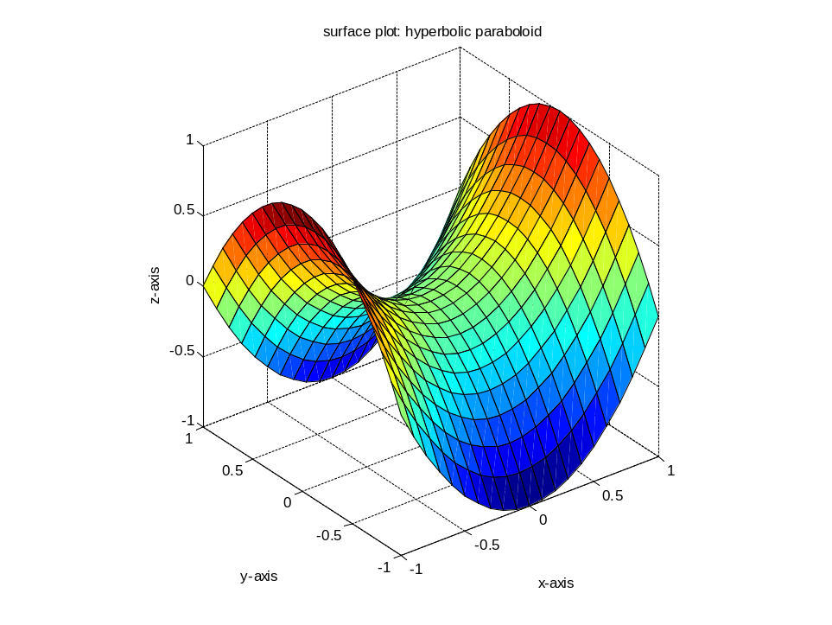
Figure 11. 3D illustration of the hyperbolic paraboloid.

For the hyperbolic paraboloid the first partial derivatives are:
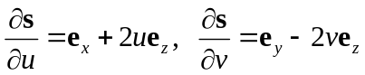
The numerator in is evaluated using such that:
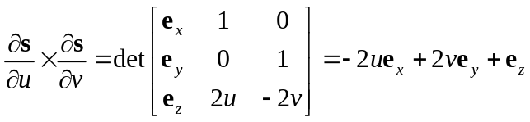
The absolute value of this vector product is:
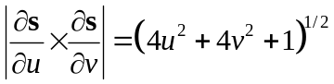
The unit normal vector for the hyperbolic hyperboloid is the ratio of and :
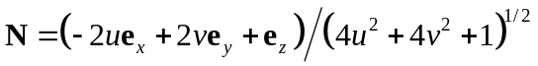
The unit normal vector for the elliptic paraboloid from (3.75) is:
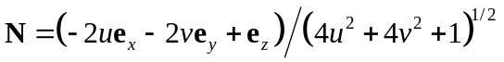
Note the only difference is the sign of the second term in the numerator. The Matlab m-script hyperbolic_paraboloid.m given above also plots a 3D image of the surface with the unit normal vectors at the intersections of the wire mesh using .

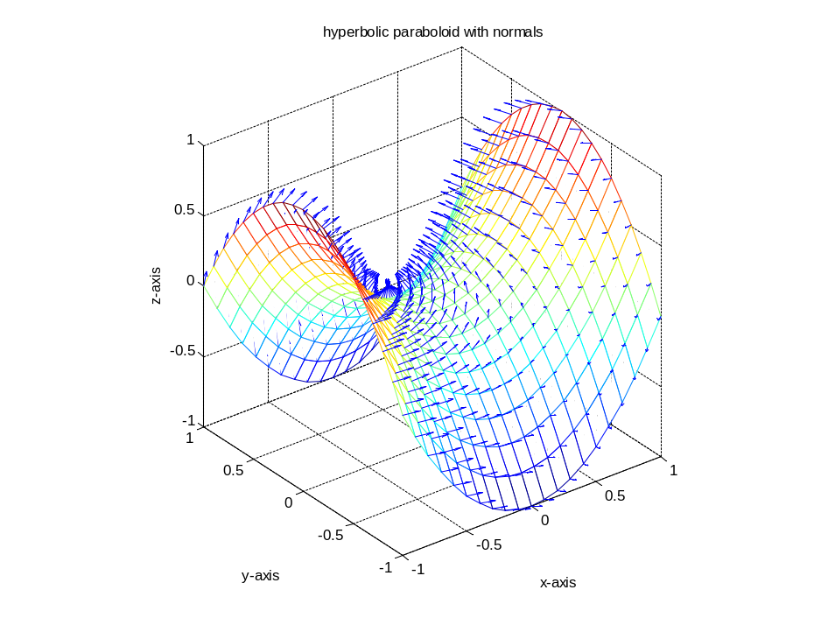
Figure 12. 3D illustration of the hyperbolic paraboloid with unit normal vectors.

12) The first and second fundamental forms are used to characterize the local shape of surfaces (Fig. 3.29) including familiar shapes of geological surfaces (Fig. 3.32). As an example consider the hyperbolic paraboloid which is better known in the geological context as a saddle structure:
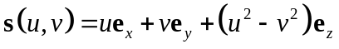
a) Derive equations for the coefficients [E(u, v), F(u, v), G(u, v)] of the first fundamental form for the hyperbolic paraboloid and write down the equation for the first fundamental form, I.
b) Derive equations for the coefficients [L(u, v), M(u, v), N(u, v)] of the second fundamental form for the hyperbolic paraboloid and write down the equation for the second fundamental form, II.
c) Use the coefficients of the second fundamental form to identify whether the point on the hyperbolic paraboloid at the origin (x = y = z = 0) is elliptic, hyperbolic, parabolic or planar. What can you conclude about the shape at an arbitrary point on the hyperbolic paraboloid?
d) The normal curvature, κ_{n}, for a surface is given in (3.120) by the ratio of the two fundamental forms, κ_{n} = II/I. Derive an equation for the normal curvature of the hyperbolic paraboloid in terms of the parameters (u, v) and their differentials (du, dv). Use the equation for κ_{n} to determine the normal curvature at the origin (x = y = z = 0) for this surface.
e) Plot the distribution of normal curvature at the origin as a function of orientation using Matlab. Hint: consider the circular path around the origin defined by du² + dv² = 1, and plot κ_{n} versus the angle measured from the u-axis. Identify the values of the principal normal curvatures and the principal directions at the origin.

The coefficients of the first fundamental form for the parametric representation of a surface s(u,v) are given in (3.85) as:
For the hyperbolic paraboloid the first partial derivatives are:
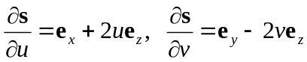
Using in the coefficients of the first fundamental form are:
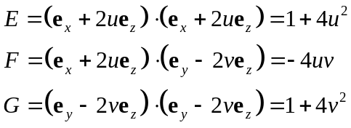
The general equation for the first fundamental form for the parametric representation of a surface s(u,v) is given in (3.85) as:
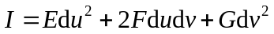
For the hyperbolic paraboloid the first fundamental form is:
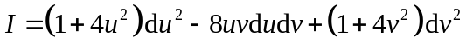
The general equations for the coefficients of the second fundamental form for the parametric representation of a surface s(u,v) are given in (3.109) as:
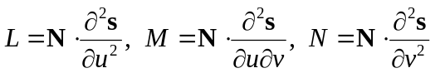
The unit normal vector for the hyperbolic paraboloid is given in as:
The second partial derivatives are found using such that:
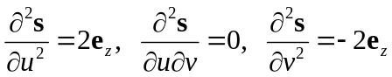
Taking the scalar products of the unit normal vector and the appropriate second partial derivative as indicated in , the coefficients of the second fundamental form are:
The general equation for the second fundamental form for the parametric representation of a surface s(u,v) as given in (3.106) is:
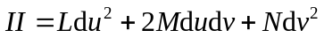
The second fundamental form for the hyperbolic paraboloid is written using the coefficients as:
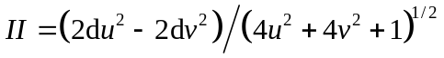
The shape of a surface at a given point to second order is determined by the combination of coefficients LN – M² as described in (3.110). For the hyperbolic paraboloid we have:
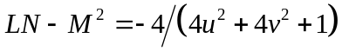
At the origin of the coordinate system the shape is determined by:
Because the combination of coefficients is negative this is a hyperbolic point. In general, from we see that all points are hyperbolic.
The normal curvature for the hyperbolic paraboloid is found from and such that:
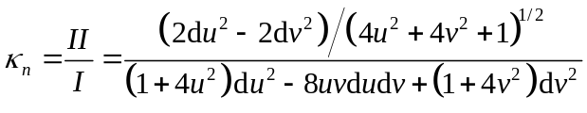
At the origin of coordinates the normal curvature is:
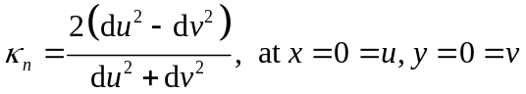
The differential quantities du and dv may be written in terms of the angle θ measured from the positive x-axis as illustrated in the following figure:

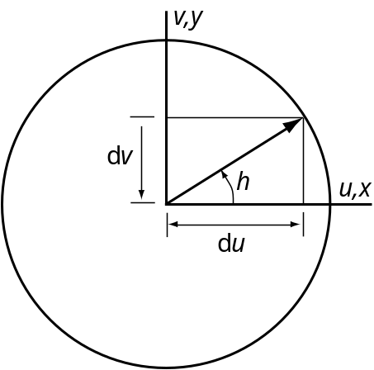

Figure 13. Circular path defined by du² + dv² = 1 around the origin for the hyperbolic paraboloid.

The differentials are:
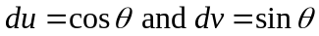
The circular path is written:
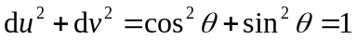
The normal curvature from is:
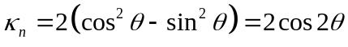
The Matlab m-script hyper_para.m plots a 2D distribution of the normal curvature at the orgin.

% hyper_para.m
% plot the distribution of normal curvature at the origin
TH = 0:pi/180:2*pi; THD = TH*180/pi; % Angle theta
figure, plot(THD,2*(cos(TH).^2 -sin(TH).^2))
axis([0 360 -2.5 2.5])

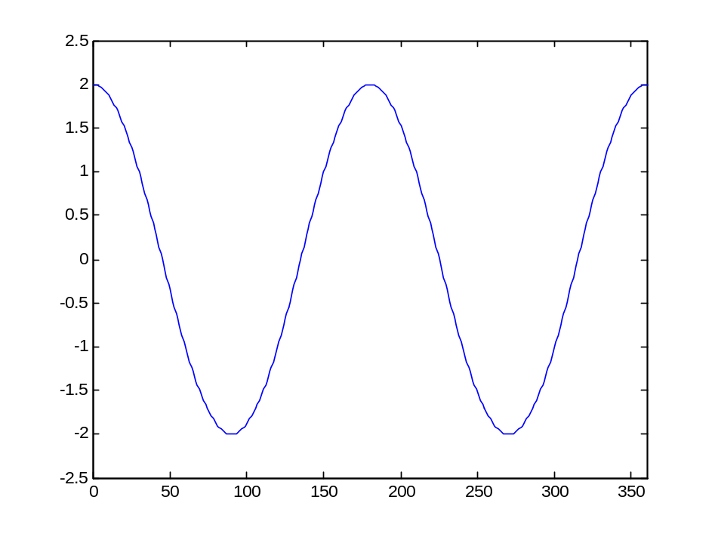
Figure 14. 2D distribution of the normal curvature at the orgin for the hyperbolic paraboloid.

