Exercise solutions: concepts from chapter 7

1) In the following exercise we consider some of the physical quantities used in the study of particle dynamics and review their relationships to one another. The two force vectors written:
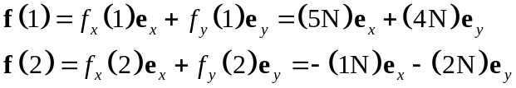
The vector scale in Figure 1 (below) may be used to verify the magnitudes of each component and to confirm that the signs of these components are consistent with the direction of the vectors.

a) Calculate the two components (F_{x}, F_{y}) of the resultant force F acting on the particle and draw that vector properly scaled on Figure 1.

Using (2-12), the components of the sum of the two vectors given in are:
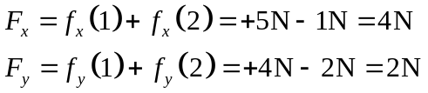
The component of the resultant force in the z direction is identically zero. F is drawn in Figure 1 below with properly scaled components.
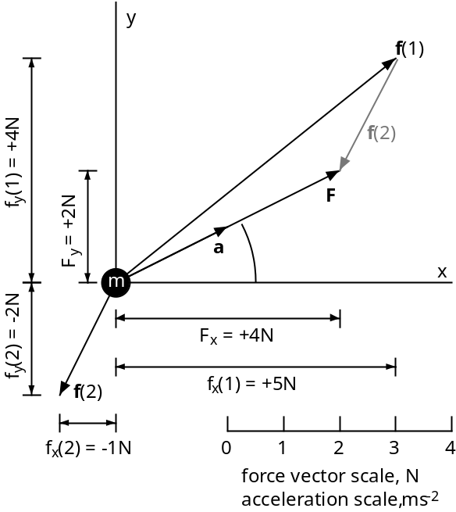
Figure 1. Schematic drawing of a point mass acted upon by the two forces given in . The resultant force is F and the corresponding acceleration is a.

b) Calculate the magnitude, F, and direction, α(F), of the resultant force F. Here the angle α(F) is measured in the (x, y)-plane counterclockwise from Ox.

The vector has a magnitude, F, given using (2.7) and direction, α(F), given using (2.10):
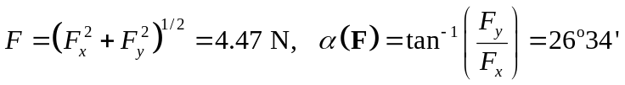
Note that one could construct the resultant vector graphically by translating the arrow f(2) until its tail is at the head of f(1), and then by drawing the arrow F from the particle to the head of f(2). The translated f(2) is shown in gray tones on Figure 1.

c) Calculate the two components (a_{x}, a_{y}), the magnitude, a, and the direction, α(a), of the acceleration, a, and draw that vector on Figure 1 with the appropriate scale. Compare the direction of the resultant force and the acceleration. By what factor do the magnitude and the acceleration differ?

Given a mass of 2 kg, the components of acceleration of the particle are:
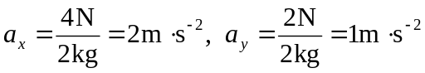
Both components of acceleration are constant with respect to time because the applied forces are constant. The magnitude and direction of the acceleration vector are:
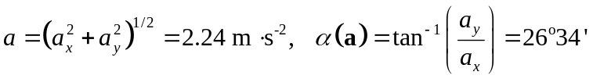
Note that the acceleration vector and the resultant force vector in Figure 1 act in exactly the same direction, that is α(F) = α(a). In magnitude, the acceleration differs from the resultant force by a factor of 1/m = 1/(2 kg).

d) The initial velocity is given as the two velocity components, v_{x}(0) and v_{y}(0):
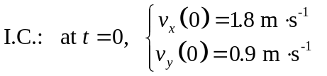
Calculate the magnitude, v₀, and direction, α(v₀), of the initial velocity vector.

The magnitude and direction of the initial velocity vector are:
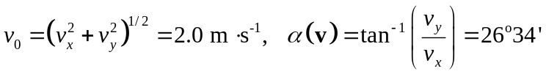

e) Calculate the components [p_{x}(0), p_{y}(0)], the magnitude, p₀, and the direction, α(p₀) of the initial linear momentum of the particle. Compare the direction of the linear momentum to that of the acceleration and resultant force.

Given the 2 kg mass of the particle, the components of the initial linear momentum are:
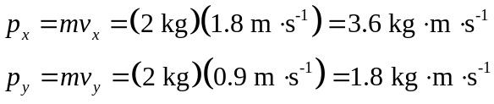
The magnitude and direction of the initial linear momentum vector are:
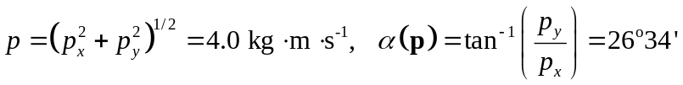
The particle moves in the direction of the resultant force and therefore in the direction of all the vector quantities that we have described (acceleration, velocity, and momentum).

f) Calculate the instantaneous velocity components (v_{x}, v_{y}) and the magnitude, v, and direction, α(v), of the velocity at the time t = 5 s.

The relation v = at + v(0) is written in terms of the respective components to find:
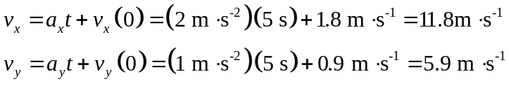
The magnitude and direction of this instantaneous velocity vector at t = 5 s are:
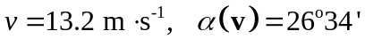
The particle has accelerated from about 2.0 m·s⁻¹ at t = 0 to about 13.2 m·s⁻¹ after just five seconds.

g) Calculate the instantaneous linear momentum components (p_{x}, p_{y}) and the magnitude, p, and direction, α(p), of the linear momentum at the time at t = 5 s.

The instantaneous linear momentum components at t = 5 s are:
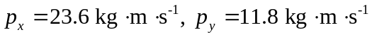
The magnitude and direction of the linear momentum vector are:
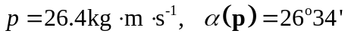
The linear momentum has increased from about 4 kg m s⁻¹ to 26.4 kg m s⁻¹ in the five-second interval.

h) Calculate the time derivatives of the components of linear momentum at t = 5 s. These are the respective components of the resultant force acting on the particle. Compare this resultant force to that applied at t = 0 s to show that you have come full circle back to the applied force.

The time derivatives of the components of linear momentum are:
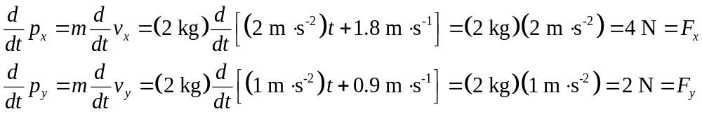
These time derivatives of the momentum components are the respective components of the constant resultant force acting on the particle as shown in Figure 1.

2) For this exercise on rigid body dynamics and statics we consider a block of granite quarried from Milford, Massachusetts, and placed on two parallel cylindrical rollers on a horizontal surface (Figure 2). The average mass density of the granite is 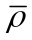 and the volume of the block is V. The Cartesian coordinate system is oriented with the z-axis vertical, the x-axis parallel to the cylindrical rollers, and the y-axis perpendicular to the rollers.
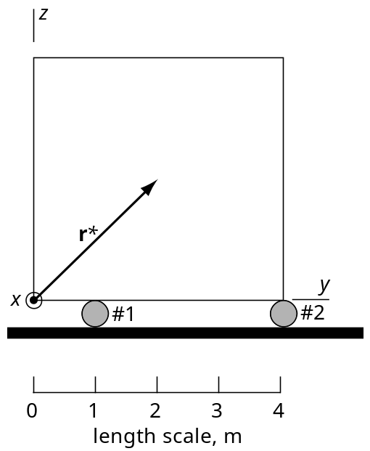
Figure 2. Schematic two-dimensional drawing through the middle of the quarried block of Milford granite.

a) Write down the general vector equation for the linear momentum of the block of granite, P, as a function of the velocity of the center of mass, v*. Relate the time rate of change of the linear momentum to the resultant surface force, F(s), and body force, F(b), both acting at the center of mass, in order to define the law of conservation of linear momentum for this rigid body. Modify this relationship for the case where the granite block is at rest on the rollers. How would this change if the block were moving with a constant velocity in the y coordinate direction on the rollers?

Because neither the volume nor the average density is a function of time for the rigid body, the linear momentum of the block may be written in terms of the time derivative of the position vector, r*, for the center of mass:
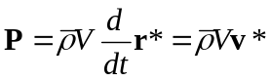
The velocity at any location other than the center of mass may be different from v*, but the behavior of the body as a whole is characterized by this velocity. The time rate of change of the linear momentum is equal to the sum of the surface and body force resultants:
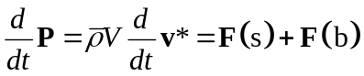
This relationship expresses the law of conservation of linear momentum. For a rigid body, subject to given surface and body force resultants, linear momentum is neither created nor destroyed spontaneously, but changes with time in strict accordance to the action of the resultant forces. If the block is at rest, v* = 0, and reduces to the static equilibrium equation:
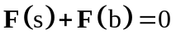
If the block were moving with constant velocity, the time derivative in would be zero, so is unchanged.

b) Assume that the block of granite is at rest on the rollers and small enough to justify a uniform gravitational acceleration, g*, which is the only body force. Suppose the n discrete surface forces acting on the block are called f(j) where j varies from 1 to n. Write down the general vector equation expressing conservation of linear momentum for the static equilibrium of the block. Assume the rollers do not impart any horizontal forces to the block and expand this vector equation into three equations expressing static equilibrium in terms of the components of the external surface and body forces.

For conditions where linear momentum does not change with time, the conservation of linear momentum dictates that the resultant of all external forces must be zero:
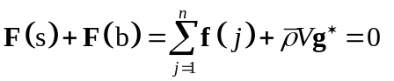
The equilibrium equations in terms of the three components of the external forces acting on the granite block reduce to:
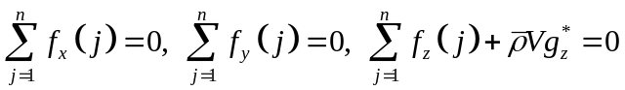
The only objects in contact with the block are the rollers and we assert that these impart no surface forces in the x- or y-directions, so the first two equations of are satisfied by definition. Because the z-coordinate is directed upward, the only non-zero component of gravitational acceleration is the z-component. The resultant surface force in the vertical direction exactly balances the gravitational body force.

c) Construct a two dimensional free-body diagram through the center of mass (and center of gravity) of the granite block in a plane parallel to the (y, z)-plane in which the resultant body force is represented by the vector F(b), and the two surface forces due to rollers #1 and #2 are represented by f(1) and f(2), respectively. All of these forces are directed parallel to the z-axis. Place the origin of coordinates at the lower left corner of the block. The average density of the Milford granite is 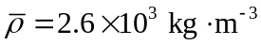, the acceleration of gravity component is 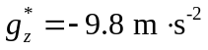, and the block is a cube 4 m on a side. Use the condition of static equilibrium for external forces to write an equation relating the magnitudes of the surface forces imparted to the block by rollers #1 and #2 to the magnitude of the gravitational body force. Can you deduce the individual magnitudes of the surface forces? Explain your reasoning.

Using the third equilibrium equation and the data given above we find:
The two surface forces can not be determined separately from this relationship; only their sum is found constrained to be:
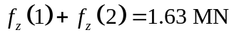
The free body diagram is given below as Figure 3.
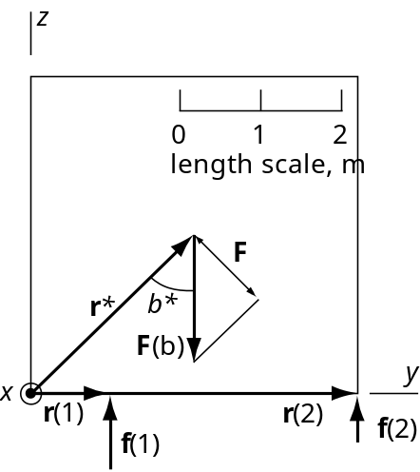
Figure 3. Free body diagram through the center of mass of the granite block in the (y, z)-plane with external body and surface forces directed parallel to the z-axis.

d) Imagine removing roller #2 from beneath the granite block and explain qualitatively what would happen and why this would happen based on Figure 3. Use the law of conservation of angular momentum to write the general vector equation relating the angular momentum of the rigid body, Φ, to the resultant torques associated with the external surface and body forces. Rewrite this equation for the special case of static equilibrium (e.g. both rollers in the positions shown in Figure 3) under the action of discrete external surface forces, f(j), where j varies from 1 to n, and the resultant gravitational body force, 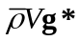, acting at the center of mass.

If roller #2 were removed the block would rotate clockwise until the lower right-hand corner impacted the surface on which the rollers rest. The general vector equation expressing conservation of angular momentum for a rigid body is:
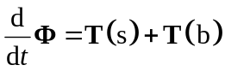
On the right-hand side are the resultant external torques, T(s) and T(b), due to the surface and body forces respectively. For static equilibrium the time derivative of the angular momentum is identically zero, so for n discrete surface forces and gravity we have:
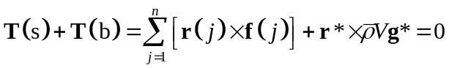
Equations and define the conditions for static equilibrium of the rigid body.

e) Use conservation of angular momentum to write an equation relating the magnitudes of the surface forces imparted to the granite block by rollers #1 and #2. From the symmetry of the problem depicted in Figure 3 it should be understood that all of the forces act in the (x, z)-plane parallel to the z-axis. Using this relationship and the other such relationship found in part c) solve for the magnitudes of the two surface forces imparted by the two rollers. Explain the difference between these two forces. How could you change the position of roller #2 such that the forces are equal? Given the configuration in Figure 2, what are the forces imparted by the rollers when roller #1 moves one meter to the right?

From Figure 3 we evaluate the position vectors and angles used to solve as follows:
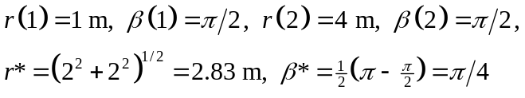
The magnitude of the body force is found using the average density and volume of the block:
From we have:
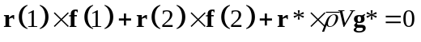
Recalling that the magnitude of a vector product is given as 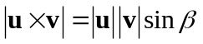where β is the smaller of the two angles between the vectors, we write as:
Note that the surface forces are associated with positive torques whereas the torque due to the body force is negative. Substituting from and to evaluate we find:
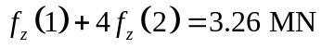
We now have two independent equations for the z-components of the surface forces. Solving simultaneously by subtracting from we have:
Substituting this value of f_{z}(2) into we find:
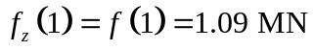
In other words, roller #1 carries twice the load of roller #2 due to it position closer to the center of the block. Moving roller #2 one meter to the left would balance the loads. Moving roller #1 one meter to the right would place it directly under the center of mass. In this case the forces imparted by the rollers would be:
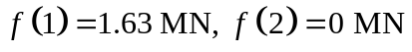

3) The theories of elastic solid mechanics and viscous fluid mechanics have been developed from quite different points of view with respect to the coordinate systems chosen to describe the positions of particles in motion. In this exercise we review these coordinate systems and the respective referential and spatial descriptions of motion.

a) Consider the kinematics of the opening of the igneous dike near Alhambra Rock, Utah. Using the outcrop photograph (provided electronically as a .jpg file), remove the dike and restore the siltstone blocks to their initial configuration. Draw a two-dimensional Lagrangian coordinate system on both the initial and the current state photographs. Illustrate the displacement, u, of a particle of siltstone on the dike contact using the two state description of motion such that:
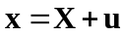
Here X is the initial position of the particle and x is the current position. Describe why this description of motion is referred to as ‘two state’. What might you learn about the intervening states from this description?

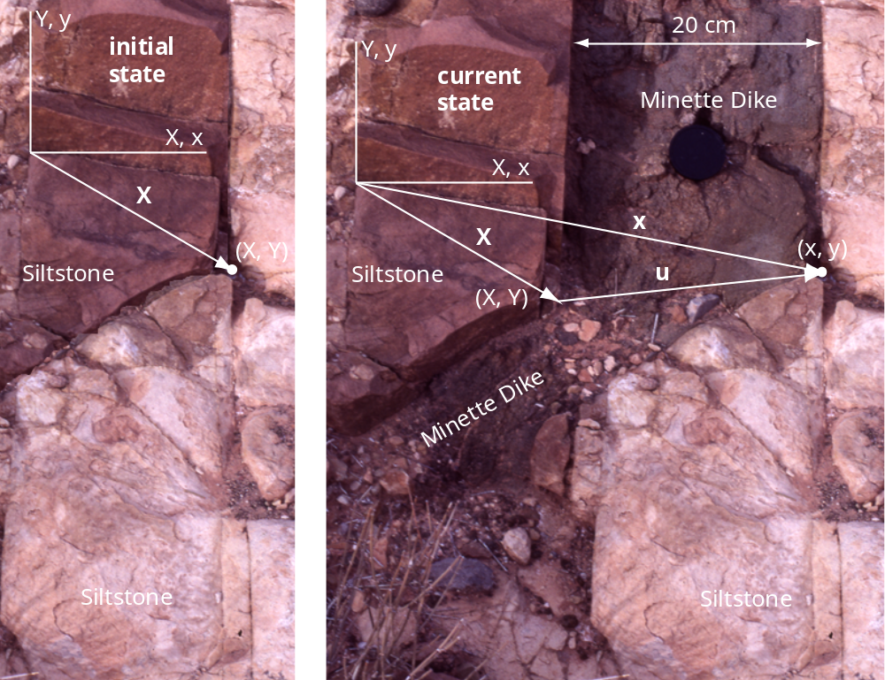
Figure 4. Outcrop photograph of Minette Dike near Alhambra Rock, Utah. On the left is the inferred initial state before dike emplacement. On the right is the current state. The particle on the right-hand dike contact is shown as a small white dot.

Note that the coordinate system is fixed to the same particle on the left-hand block of siltstone in both the initial and current states. The jog in the left-hand and right-hand dike contacts may be fit together like pieces of a jigsaw puzzle. With this restoration of the initial state note that fractures in the adjacent blocks of siltstone match across the contacts. This provides additional evidence that the restoration is correct and also indicates that these fractures predate the dike opening.

This description of motion is referred to as ‘two state’ because only the initial and current states are described. The position vector for the particle in the current state, x, is given in as the sum of the position vector in the initial state, X, and the displacement vector, u. Nothing is learned about the intervening states from this description. A simple possibility is that the particle moved along the straight line defined by the displacement vector, but the outcrop data only constrain the particle to be in one or the other of the two states illustrated here. The path that the particle traveled along and its velocity at each point along that path are not included in this two state description of motion.

b) A complete referential description of the particle motion near the dike would be given as:
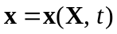
Here t is time which progresses continuously from the initial state (t = 0) to the current state. Indicate why this description is called ‘referential’. The particle velocity is given as:
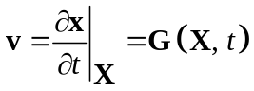
Explain why this is called the ‘material’ time derivative. Provide the general equation for calculating the acceleration, a, of an arbitrary particle given the function x(X, t) in . What property must this function have to carry out the calculation of the particle acceleration?

The description of motion given in is called ‘referential’ because for every time, t, the current coordinates of a given particle, x, depend on the coordinates, X, of that particle in the initial state. Knowledge of each current state requires one to refer back to this particular initial state. The complete path followed by a given particle is defined in this way. We do not know the function for particles near the dike in Figure 4, but this could be derived for a model dike using continuum mechanics.

The partial derivative of x in is referred to as a ‘material’ time derivative because the independent variable, X, which is the position vector for particles in the initial state, is held constant during partial differentiation with respect to time. This procedure enables one to calculate the velocity of any particle as it changes with time from the initial to the current state. The velocity, v, defined in is the called the particle velocity.

The particle acceleration, a, is defined as:
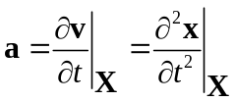
The function x(X, t) in must be twice differentiable with respect to time to carry out this calculation.

c) Consider the development of foliation and folds in the Dalradian quartzites and mica schists at Lock Leven, Scottish Highlands (Weiss and McIntyre, 1957). Suppose each sketch represents a snapshot in time t during the evolution of the foliation and folds. Draw the same two-dimensional Eulerian coordinate system adjacent to each of the four sketches and choose a particular location within these sketches defined by the same position vector x. Schematically draw the local velocity, v, of particles at x for stages b, c, and d using the spatial description of motion such that:
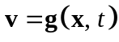
Indicate why this is referred to as a ‘spatial’ description of motion and in doing so explain why v in is referred to as the ‘local’ velocity.

Two-dimensional Eulerian coordinates (x, y) are shown in Figure 5 along with the current position, x, and a schematic vector for the local velocity vector v for stages b, c, and d. Note that the local velocity at x may change in both magnitude and direction as the structure evolves.
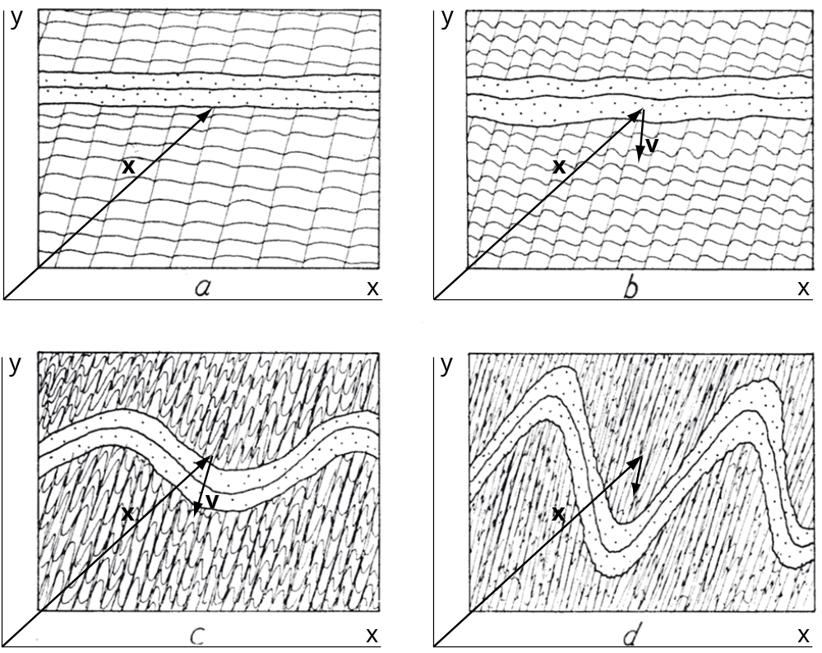
Figure 5. Drawings of stages in the development of foliation and folds in Dalradian quartzites and mica schists at Lock Leven, Scotland (Weiss and McIntyre, 1957).

Equation is referred to as a spatial description of motion because x is a fixed position in space at which the velocity, v, varies as a function of time, t. As time progresses different material particles pass through this position, but the velocity is associated with the position in space not a particular particle. In this sense v is the local velocity.

d) For a complete spatial description of motion during folding the function g(x, t) in would describe the velocity at every position x for all times from t = 0 to t = current. Given such a function one could take the time derivative holding the current position constant:
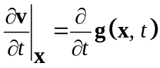
Explain why this is called the local rate of change of velocity and not the particle acceleration.

Consider a steady state flow regime such as that illustrated in Figure 5.12a for a buoyant sphere of viscous fluid rising in another viscous fluid. Note that the velocity vectors vary with position in the sphere but do not vary with time. Every snapshot of the sphere would have the same velocity distribution. Therefore the quantity defined in would be identically zero: the velocity at a given position x does not change with time. However, consider a given particle of fluid moving along one of the circuits illustrated by the streamlines in Figure 5.12b. As this particle passes from a region of lesser velocity (e.g. near the perimeter of the sphere) to one of greater velocity (e.g. near the center of the sphere) it is accelerating. Therefore the particle acceleration is not zero and it can not be defined by which only defines the local rate of change of velocity.

e) The particle acceleration, a, may be calculated, given the local velocity, v, defined in and a spatial description of motion, using the following equation:
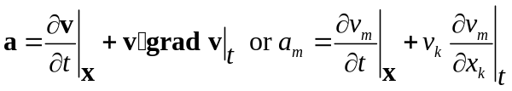
Here grad v is the gradient with respect to the spatial coordinates of the local velocity vector. Write out the component a₁ of the particle acceleration. Compare and contrast this definition of the particle acceleration with that defined using a referential description of motion:
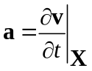

Using the second equation of the first component of the particle acceleration is:
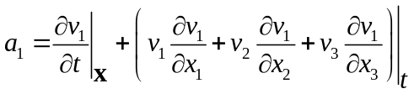
The first term on the right-hand side of and is the local rate of change of velocity as defined in . Thus, the particle acceleration, a, differs from the local rate of change of velocity by the second term on the right-hand side of and . This second term is the product of the local velocity at x and the spatial derivatives of the velocity at the current time t. In other words this is the rate of change of velocity at x due to the flow of material with a spatially varying velocity field through this point.

4) The underlying assumptions used to balance cross sections are geometric and kinematic, that is they specify geometric quantities and displacements. A common assumption is that area (or volume) is conserved. Like other solids and fluids tested to characterize their mechanical behavior, rock deforms such that mass is conserved. In this exercise we explore the concept of mass conservation in order to understand what kinematic consequences follow from adopting this “law of nature.”

a) To balance a cross section of the Sprüsel fold from the Jura Mountains, Switzerland, Laubscher assumed a kink fold geometry with straight limbs and sharp angular hinges. His geometric method is illustrated in Figure 6 where we see a fold, made up of two complementary kink bands, in the sedimentary strata terminating downward at a mobile layer resting on a detachment (décollement) at the top of a rigid basement. The strata and mobile layer are deformed by a uniform horizontal displacement along the left edge of the model, but neither the strata nor the mobile layer change thickness. The strata accommodate the deformation by kinking while the mobile layer accommodates the deformation by extruding material into the triangular void.
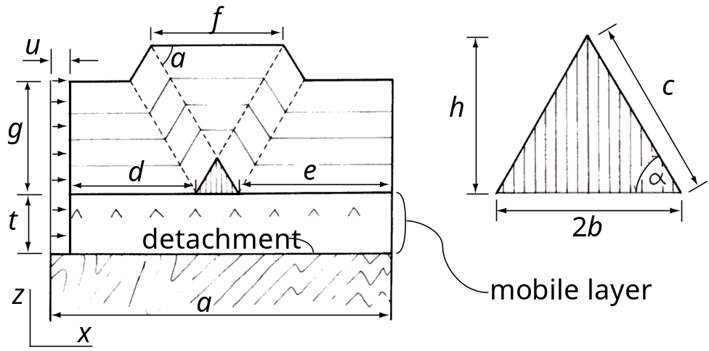
Figure 6. Geometric and kinematic model for a kink band style of folding with a mobile layer and a detachment (redrawn and annotated from Laubscher, 1976).

Use conservation of line length to relate the length of the kink fold limb, c, and dip of the kink band, α, to the horizontal displacement, u. Derive the equation for the area of the triangular void, A_{T}, as a function of the limb length, c, and dip, α. Use conservation of area to equate A_{T} to the area removed, A_{R}, from the mobile layer as is shortens without thickening. Combine your results to derive Laubscher’s equation for thickness, t, of the mobile layer. Derive an equation for the depth to the detachment from the upper surface of the fold created by the two complementary kink bands as a function of the width of this surface, f, the limb length, c, and dip, α.

Conservation of line lengths along the top of the mobile layer and the base of the sedimentary strata requires the following:
Rearranging we solve for the displacement and substitute for the base of the triangular void using the trigonometric relation from Figure 6, 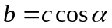, to find:
The area of the triangular void is:
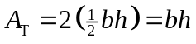
However, we from Figure 6 we have and 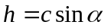. Substituting into we find:
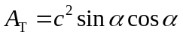
The area of the mobile layer that is removed as it shortens without thickening is the product of the thickness, t, and the horizontal displacement, u:
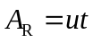
Substituting for u from into :
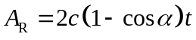
Conservation of area requires that the area of the triangular void is equal to the area of the mobile layer removed, A_{T} = A_{R}, so combining and we have:
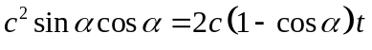
Rearranging to solve for the thickness of the mobile layer we find:
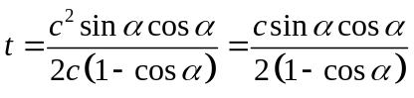
This is Laubscher’s equation. The depth to the detachment, D, from the upper surface of the fold is:
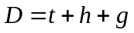
Note from Figure 6 that and 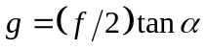. Also, t is given in so combining these equations by substituting into we have:
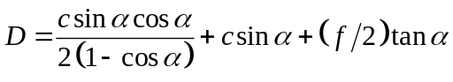

b) Now that the roles of conservation of line length and of area have been elucidated in the context of cross section balancing, consider the alternative: conservation of mass. Start with a volume element that is fixed in space at a location x in the evolving Sprüsel fold using a spatial description of motion. Sedimentary rocks pass through this volume element as they are folded. For the sake of a simple example suppose, at some moment in time, t, that the velocity at the center of this volume element is directed exactly upward in the positive z-coordinate direction, so v(x, t) = v_{z}e_{z}. The mass density of the rock also is a function of the current location and time, that is ρ = ρ(x, t). Derive the one-dimensional equation for the temporal rate of change of mass density, 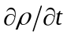, in terms of the mass flux per unit volume in the z-direction, ρv_{z}. Explain each step in your derivation starting with a word description of conservation of mass.
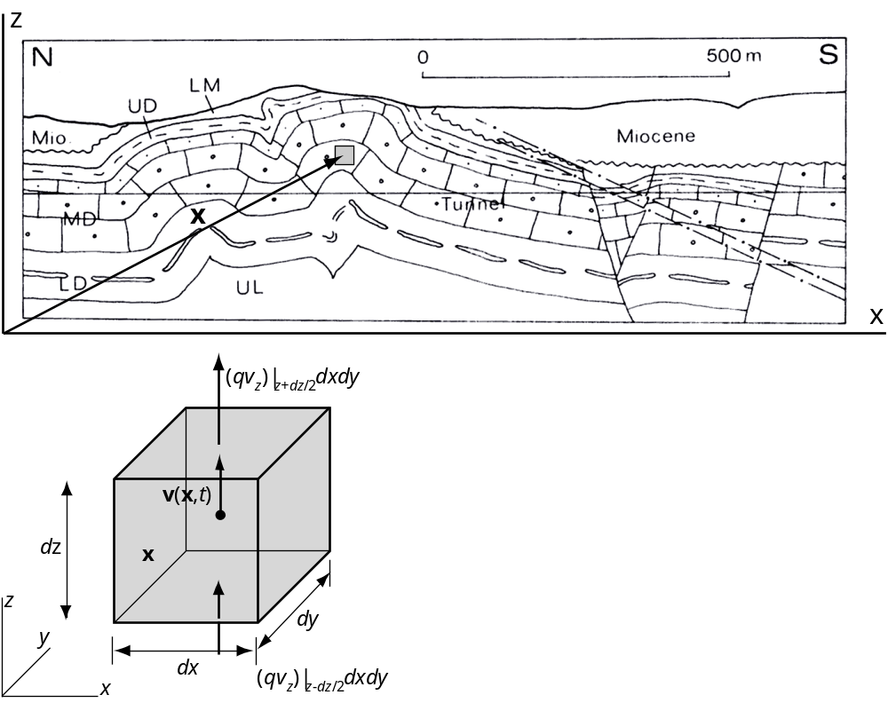
Figure 7. Cross section constructed by Buxtorf of the Sprüsel fold. A fixed volume element is located at position x and at some time t the velocity is directed upward. Vectors represent the mass flux per unit volume, ρv_{z}, on the bottom and top.

Conservation of mass for the volume element is described in words as:
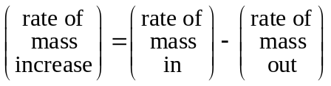
For the special conditions of this problem mass only enters the volume element across the bottom surface and it only leaves across the top surface because the velocity is exactly upward: v(x, t) = v_{z}e_{z}. The rate of mass increase (left-hand side of ) is measured by the temporal derivative of density times the volume:
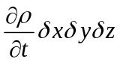
Each term on the right-hand side of is found using the mass flux per unit volume, ρv. Here the only non-zero component of the velocity is v_{z} so we take the product of the mass density and the z-component of velocity evaluated at the bottom and the top of the element. These quantities are multiplied by the respective surface areas to account for flux through the entire bottom and top of the element. The total mass flux per unit volume into the element through the bottom less the total mass flux per unit volume out of the element through the top is:
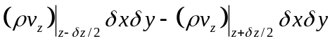
Multiplying and dividing by δz, we write:
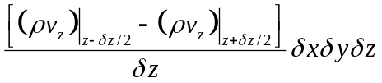
Note that the leading term in approximates the negative of the spatial derivative of mass flux per unit volume in the z-direction. This may be understood by considering a set of n elements containing the point x, with successively smaller volumes that approach zero in the limit as the number of elements goes to infinity:
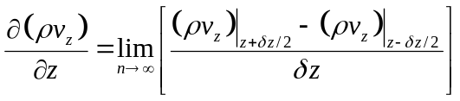
Dividing and by the volume of the element, 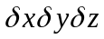, and using the negative of we write:
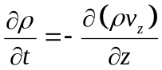
This is a one-dimensional description of mass conservation at the point x for the special case where the velocity is along the z coordinate. In words, the time rate of change of mass density is equal to the negative of the spatial gradient in mass flux.

c) Expand the spatial derivative of the mass flux in your result from part b) assuming both density and velocity vary with z. Provide a physical interpretation for both terms of this expansion.

The right-hand side of is expanded for the case where both mass density and the z-component of velocity are functions of the z coordinate as follows:
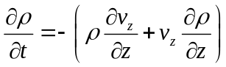
The first term on the right-hand side accounts for gradients in velocity with mass density held constant. For a positive gradient in velocity in the z-direction the velocity of material moving into the element through the bottom (see Figure 7) is less than the velocity of material moving out through the top. This leads to a stretching of the material within the element. Consistent with the negative sign in front of this term, the associated change is a decrease in the mass density near x with time.

The second term on the right-hand side accounts for gradients in mass density with velocity held constant. For a positive gradient in mass density in the z-direction the density of material moving into the element through the bottom is less than the density of material moving out of the element through the top. Consistent with the negative sign in front of this term the associated change is a decrease in the mass density near x with time. Density at a fixed point in a material continuum can change by either one (or both) of these two independent mechanisms while mass is conserved.

d) The equation derived in part b) is the one-dimensional form of the three-dimensional scalar equation of continuity:
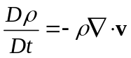
Show what is hidden on both sides of the equation of continuity by expanding in terms of partial derivatives of density and of the velocity components.

The material time derivative on the left-hand side of is expanded as:
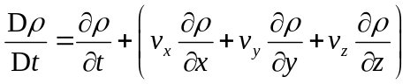
Note that this includes the temporal change in mass density and three terms that account for changes due to gradients in mass density in each coordinate direction.

The differential operator, 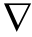, on the right-hand side of is expanded as:
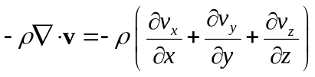
Note that this includes changes due to gradients in velocity in each coordinate direction.

e) A common postulate employed in modeling the flow of rock using viscous fluid mechanics is that the left side of is identically zero. In other words the mass density in the immediate surroundings of any particle does not change with time. With these constraints the rock is described as incompressible. What does this imply about the kinematics of the deformation in general? Suppose the mobile layer under the model Sprüsel fold (Figure 6) behaved approximately as an incompressible material. What does this imply about the velocity gradients on the right-hand side of ?

If the left-hand side of is zero than the kinematic terms on the right-hand side must be zero. These are given explicitly on the right-hand side of , so we have:
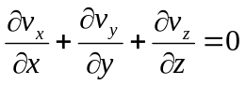
In other words, for all relevant times and near any particle in the incompressible material continuum, the velocity gradients are constrained such that a stretch in one coordinate direction is compensated exactly by a contraction in one or both of the other coordinate directions. Clearly the constraint of being incompressible does not imply that a material is rigid. The incompressible material can deform by stretching and contracting, or by shearing. As the mobile layer under the model Sprüsel fold (Figure 6) shortens the velocity gradient, 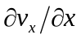, must be non-zero and negative. This implies that 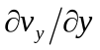 and/or 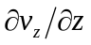 must be non-zero and positive. In other words the shortening along the length of the layer must be accompanied by flow out of the plane of the cross section (in the y-coordinate direction) and/or by vertical flow (in the z-coordinate direction) leading to an increase in thickness of the mobile layer.

f) Typically a plane strain condition is invoked for cross section balancing. Given this condition does the incompressible material behave in the same way as the material involved in balancing the cross section of the Sprüsel fold (Figure 6)? Consider separately the basement, the mobile layer, and the overlying folded strata. Laboratory tests demonstrate that rock is compressible. Qualitatively critique the assumed behavior of the model Sprüsel fold based upon this fact.

For plane strain conditions in the model Sprüsel fold (Figure 6) we have 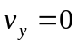. For the incompressible material reduces to:
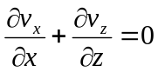
The basement is treated as perfectly rigid so 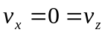. While this very special condition satisfies it is not a good description of rock.

The mobile layer is required to shorten without changing thickness, except in the vicinity of the void. The incompressible material would increase in thickness everywhere to compensate for the shortening.

The folded strata conserve length so they are perfectly rigid and , except in the vicinity of the kink bands. Again, this very special condition satisfies , but begs the question: how does the kink band form?

In summary the plain strain condition may be appropriate if the fold is long and relatively uniform in geometry in the direction perpendicular to the cross section. However, the assumptions of rigid behavior for the basement and constant length for the strata are not consistent with rock mechanics data. The assumption that the mobile layer does not thicken as it shortens requires a behavior that also is not consistent with rock mechanics data. These ad hoc kinematic assumptions are not justified and are likely to lead to significant errors in the construction of a cross section.

5) Conservation of linear momentum is the second of three conservation laws that constitute the foundation of solid and fluid mechanics as developed in chapter 7 for the study of rock deformation.

a) Consider a volume element that is fixed in space at location x in the evolving Sprüsel fold (Figure 7). Sedimentary rocks pass through this volume element as they are folded. In general, the momentum per unit volume, ρv(x, t), at the center of the element is a vector function of the current position and time. Momentum is carried in and out of the element in proportion to the velocity at the sides of the element, so we focus on the momentum flux per unit volume is v(ρv). Draw the volume element and schematically illustrate and label the z-component of momentum flux per unit volume through each side. Derive an expression for the net change of the z-component of momentum due to these momentum fluxes.

As material moves through the fixed volume element (Figure 8), momentum is carried in and out parallel to the three coordinate directions in proportion to the respective velocity components in those directions. This transport of momentum is measured by the momentum flux per unit volume, v(ρv).

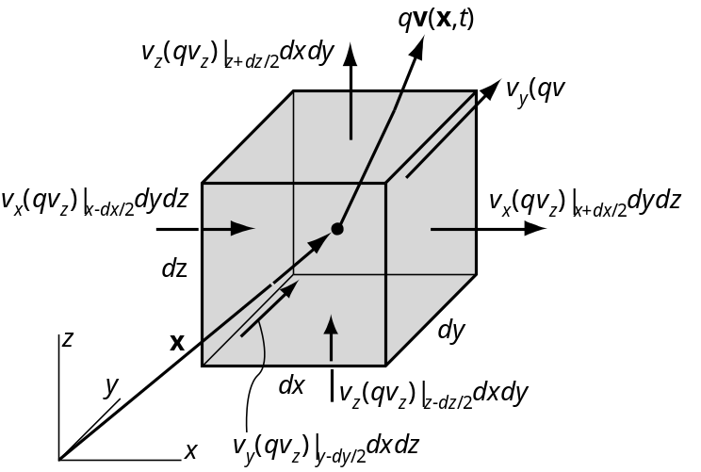
Figure 8. A fixed volume element is located at position x in the Sprüsel fold (Figure 7). Vectors represent the z-component of momentum flux per unit volume through each side.

For the sake of this example we consider only the z-component of momentum flux per unit volume. On the bottom of the element this is v_{z} (ρv_{z}) where ρ and v_{z} are evaluated at z – δz/2. This quantity times the area of the bottom, δxδy, is the momentum flux per unit volume through the bottom. The momentum flux per unit volume through the top of the element is written similarly, but ρ and v_{x} are evaluated at z + δz/2. We account for the difference between the momentum per unit volume in through the bottom and that out through the top as:
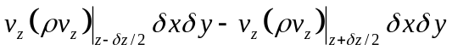
To transform this finite difference to a partial derivative with respect to the z-coordinate we multiply by δz/δz to find:
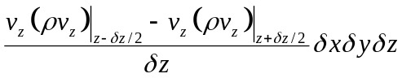
Now consider a set of n elements with successively smaller volumes that approach zero in the limit as n → ∞ and the elements converges on the central point at x. In this limit becomes the negative of the partial derivative of the momentum flux per unit volume with respect to z (times the volume):
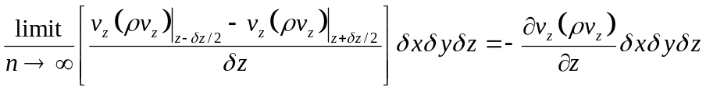
Because the velocity components v_{x} and v_{y} are parallel to the bottom and top (Figure 8), they cannot contribute to the momentum flux through these sides. On the other hand, v_{x} can carry z momentum per unit volume, ρv_{z}, through the left and right sides, and v_{y} can carry z momentum per unit volume through the front and back sides. These other two components of the change of z momentum are defined as in using the appropriate partial derivatives, so the net of change of z momentum is:
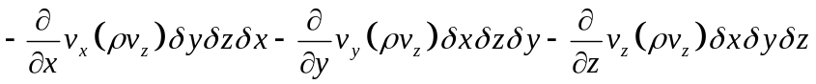

b) Generalize the expression found in part a) to three dimensions and write out the equation for the net change of momentum per unit volume, 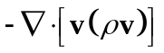, in component form. Describe how the subscripts on the velocity components conform to an ‘on-in’ subscript convention.

The momentum flux per unit volume, v(ρv), is the product of two vectors referred to as a dyadic product. The result of this operation is a nine component tensor made up of the respective products of the velocity components and the momentum per unit volume components:
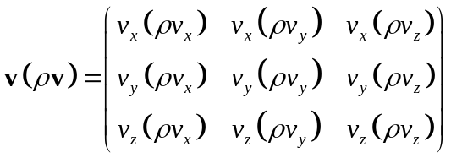
The appropriate partial derivatives of these components with respect to the spatial coordinates are found by taking the negative of and applying the del operator:
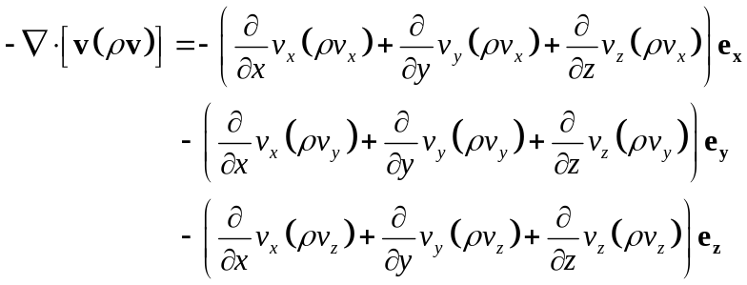
The order of the two velocity components in each term is in keeping with an ‘on – in’ subscript convention: e.g. v_{y}(ρv_{z}) is the momentum flux per unit volume ‘on’ a side with normal parallel to the y coordinate and ‘in’ the z direction. In summary, describes the net change of momentum per unit volume due to the flow of rock through the fixed volume element in the Sprüsel fold (Figure 7).

c) Conservation of linear momentum as describe in (7.84) includes a term for the resultant of all forces acting on the volume element. Draw the element and schematically illustrate and label all of the stress components and the gravitational body force components that contribute to the net force in the z-coordinate direction. Derive an expression for the net force in the z-coordinate direction.

For the sake of this example we consider only the z-component of resultant force per unit volume. On the bottom of the element the normal stress is σ_{zz} evaluated at z - δz/2 and this quantity times the area of the bottom, δxδy, is the force acting in the z-direction. The force acting on the top of the element is written similarly, but σ_{zz} is evaluated at z + δz/2. We account for the net force due to these normal stresses as:
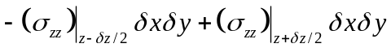
To transform this finite difference to a partial derivative with respect to the z-coordinate we multiply by δz/δz and rearrange it to find:
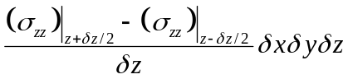

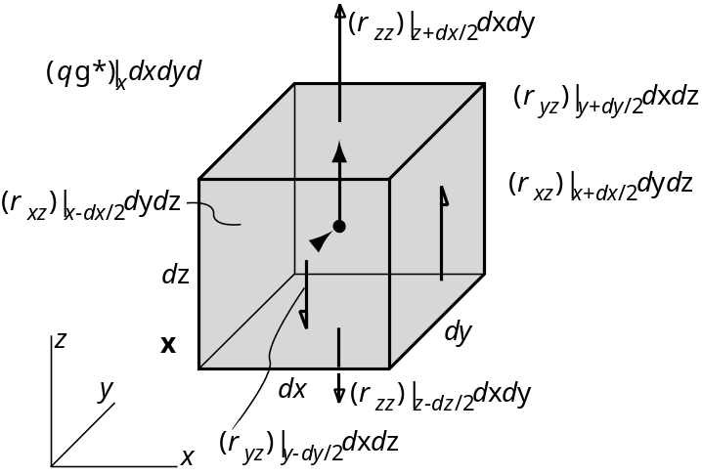
Figure 9. A fixed volume element is located at position x in the Sprüsel fold (Figure 7). Arrows represent the surface and body forces that contribute to the resultant force in the z-coordinate direction.

Now consider a set of n elements with successively smaller volumes that approach zero in the limit as n → ∞ and the elements converges on the central point at x. In this limit becomes the partial derivative of the normal stress component with respect to z (times the volume):
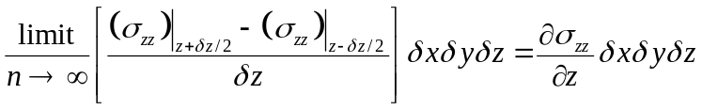
The net force in the z-direction due to the normal stress acting on the top and bottom of the element is given by the partial derivative of that stress with respect to z times the volume. The net force in the z-direction due to the shear stresses on the front and back of the element, and on the left and right sides of the element, are similarly defined with reference to Figure 9. The body force acting in the z-direction is the product of the mass density, the acceleration of gravity component in that direction, and the volume of the element:
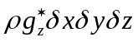
The resultant of all surface and body forces in the z-direction is:
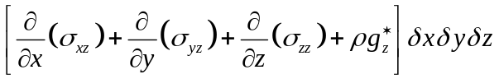

d) Generalize the expression found in part c) to three dimensions and write out the equation for the resultant force per unit volume, 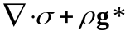, in component form.

The one dimensional expression for the net force in the z-coordinate direction may be generalized to three dimensions by adding the terms for the other six stress components and the other two body force components. Equation and the corresponding equations for the x- and y-directions are divided by the volume of the element to find:
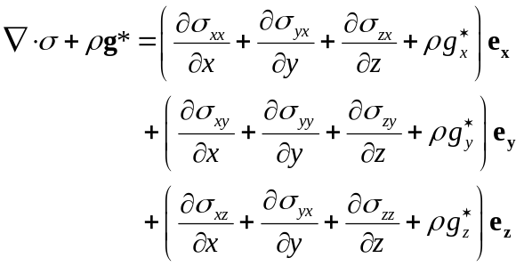
This is the resultant force per unit volume acting on the fixed volume element.

e) The rate of increase of momentum per unit volume for the fixed volume element is 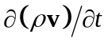. Use your results from the previous parts of this exercise to write down the z-component of this equation of motion. Write down the complete equation of motion in vector form.

The rate of increase of z momentum for the fixed volume element is given by:
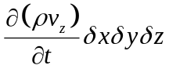
To find the rate of increase of z momentum per unit volume we divide by the volume, δxδyδz and set this equal to the appropriate terms from and to find the z-component of the equation of motion:
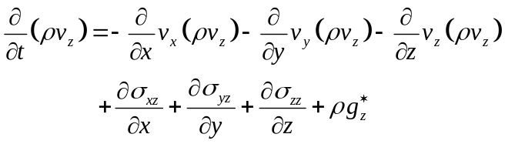
Collecting the vector expressions from and , and generalizing after dividing by the volume of the element we have:
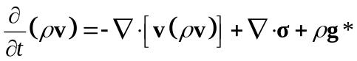
This is the spatial description of the conservation of linear momentum.

6) To address problems in structural geology the equations of motion are specialized by invoking particular constitutive properties. In this exercise we consider the isotropic, isothermal, and linear elastic solid introduced by Robert Hooke which gives the stress components, σ_{ij}, in terms of the infinitesimal strain components, ε_{ij}:
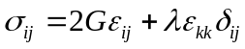
The shear modulus, G, and Lame’s constant, λ, are related to the more familiar elastic constants Young’s modulus, E, and Poisson’s ratio, ν, using:
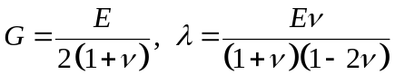
The equations of motion are written:
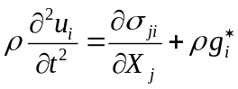
The mass density is ρ and the components of gravitational acceleration are 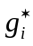. One refers deformation to the initial state and u_{i} are the displacement components.

a) The three equations of motion and the six constitutive equations are not sufficient to solve problems in linear elasticity. The six kinematic equations relating the infinitesimal strain components to the displacement components are added to this set. Start with the equation using indicial notation for the Lagrangian finite strain components and the referential description of motion. Expand this equation for the components E_{zz} and E_{xz} and show how these are simplified to define the corresponding infinitesimal strain components. Write the six kinematic equations for the infinitesimal strain components as one equation using indicial notation. Identify the fifteen dependent variables corresponding to this set of fifteen equations.

The equation for the finite strain components, E_{ij}, as a function of the displacement gradients using the referential description of motion is:
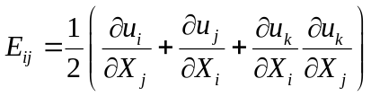
The longitudinal and shear strain components, E_{zz} and E_{xz}, are approximated as follows:
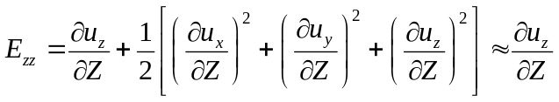
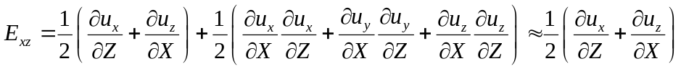
The infinitesimal strain components, ε_{ij}, are related to the displacement gradients as:
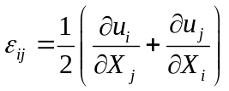
The fifteen dependent variables corresponding to equations , , and are the six stress components, σ_{ij}, the six strain components, ε_{ij}, and the three displacement components, u_{i}.

b) Show how the equation of motion is simplified by replacing the stress components with the appropriate gradients in the displacement components to derive Navier’s equations of motion. Expand and use the third equation of motion in component form to illustrate the steps of the derivation.

The equation of motion contains derivatives of the stress components with respect to the material coordinates. For example, considering the third of these equations we have:
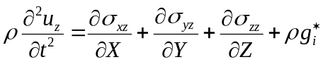
The two shear stress component in are written using as:
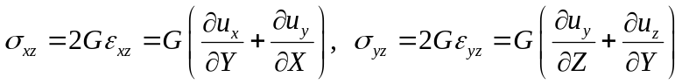
The normal stress component in is written using as:
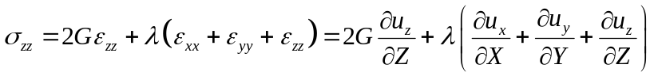
The derivatives of the stress components are found using and such that:
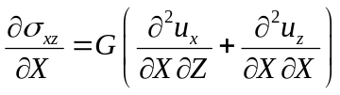
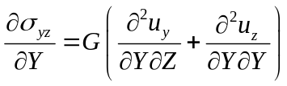
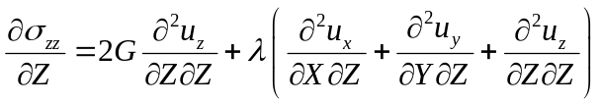
Noting the systematics of these derivatives, the equation of motion using indicial notation may be constructed as:
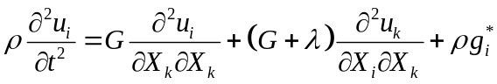

c) In some applications the strain components are treated as the dependent variables given the stress components. Derive an alternate form of Hooke’s Law by solving for the strain components and using Young’s modulus, E, and Poisson’s ratio, ν, as the elastic constants from . Hint: these two elastic moduli may be used to relate the sum of the longitudinal strains and the sum of the normal stresses as follows:
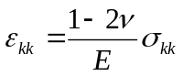
Repeating Hooke’s Law with strain components as the independent variables and stress components as the dependent variables we have:
Rearranging to solve for the strain components:
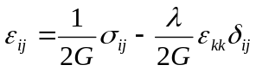
Substituting from and into we find:
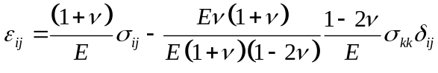
Simplifying, we have Hooke’s Law for the isotropic elastic material with the stress components as the independent variables and the strain components as the dependent variables:
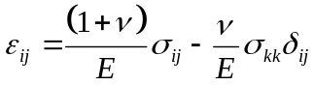

7) To address some problems in structural geology Cauchy’s First and Second Laws of Motion (7.103 and 7.122) are specialized by invoking the isotropic, isothermal, and linear viscous fluid introduced by George Stokes. This idealized material has the following constitutive relations giving the stress components in terms of the rate of deformation components:
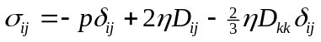
Values for the viscosity, η, are taken from laboratory experiments.

a) The six kinematic equations defining the rate of deformation components are required to write in terms of the velocity components. Write these six equations as one equation using indicial notation. Compare and contrast this kinematic equation with that relating the displacement components to the infinitesimal strain components.

The kinematic equations relating velocity to rate of deformation are:
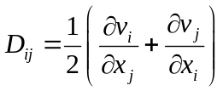
Note that the rate of deformation components, D_{ij}, are related to partial derivatives of the velocity components, v_{i}, with respect to the spatial coordinates, x_{i}. The kinematic equations relating displacement to infinitesimal strain are:
Note, in contrast to that the infinitesimal strain components, ε_{ij}, are related to partial derivatives of the displacement components, u_{i}, with respect to the material coordinates, X_{i}. Therefore, taking the temporal derivative of the right side of would change the displacements to velocities, but would not result in an expression equal to the right side of . Taking the temporal derivative of the left side of results in strain rates, but these are not the same as rates of deformation. Furthermore, the rate of deformation is not limited to small velocity gradients in the manner that the infinitesimal strain is limited to small displacement gradients.

b) Use the commonly employed constraint that flowing rock is incompressible to rewrite for the incompressible linear viscous material. Begin with a statement of conservation of mass.

Conservation of mass is described by the continuity equation (7.81):
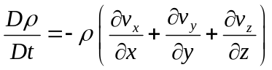
Here the derivative on the left-hand side is the material time derivative. From the definition of the rate of deformation the sum of the velocity gradients on the right-hand side of is related to the rate of deformation as:
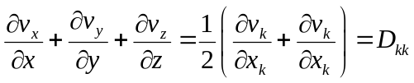
Therefore may be written:
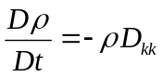
Incompressible means that the mass density does not change with time. Therefore the material time derivative must be zero:
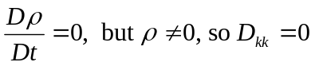
Under these conditions is modified to become:
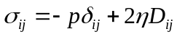

c) Substitute your result from part b) for the stress components in Cauchy’s First Law of Motion (7.103) to derive the Navier-Stokes equations for the flow of an isotropic, isothermal, incompressible, linear viscous material with constant mass density.

First use to write in terms of the velocity components:
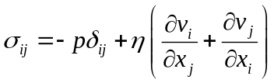
Then recall that Cauchy’s First Law of Motion is:
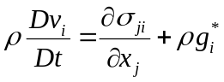
Taking the first of as an example the stress components would be:
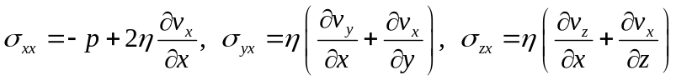
Substituting for these stress components, the first term on the right side of is:
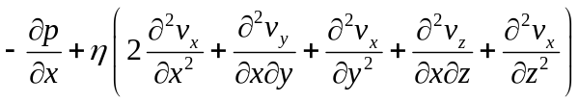
Of the terms in parentheses in , taking one half of the first term, the second term, and the fourth term note that:
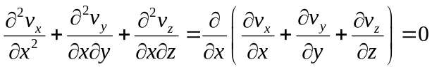
This is equal to zero because we have specified incompressibility . Using what is left of in the first of we have:
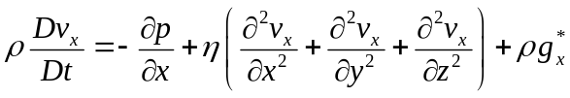
This is the first of the Navier-Stokes equations which are summarized using indicial notation as:
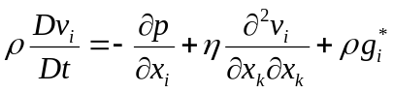

d) Identify the four independent variables and the four dependent variables in the Navier-Stokes equations. What is the fourth equation needed to solve for the four dependent variables? Write it down using indicial notation.

The four independent variables are the three spatial coordinates, x_{i}, and time, t. The four dependent variables are the three velocity components, v_{i}, and the pressure, p. The fourth equation of this set is the compatibility equation for the incompressible fluid:


