Exercise: mapping dikes at Ship Rock

Reading: Fundamentals of Structural Geology, Ch. 2, p. 25 – 47
Delaney & Pollard, 1981, Deformation of host rocks and flow of magma during growth of minette dikes and breccia-bearing intrusions near Ship Rock, NM. USGS Professional Paper 1202, p. 1 – 13

The field data for this exercise come from the Ship Rock region of northwestern New Mexico which is described in USGS Professional Paper 1202. The data are manipulated in Matlab to construct a map of the contact of the northeastern dike (see Figure 1) using the UTM projection and grid system. In this exercise you will employ mathematical formulae for translation and rotation to transform field data from a local coordinate system to a map with standardized coordinates. Finally, you will investigate thickness variations along the dike and relate these variations to two different physical mechanisms operating during dike emplacement.

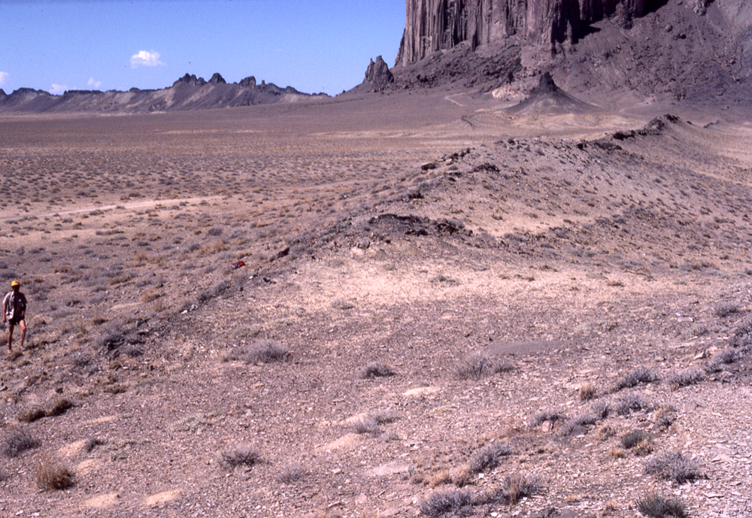
Figure 1. Paul Delaney examines the contact of a segment of the northeastern dike at Ship Rock, New Mexico. The base of the Ship Rock edifice, the small volcanic neck (shown in Fig. 2.10, textbook), and the large southern dike may be seen in the background.

1) Two sets of two-dimensional position vectors, p(i) and q(i), are used to map the contact between the Mancos Shale and the igneous rock of the northeastern dike with p(i) locating the northwestern side of the dike and q(i) the southeastern side (Fig. 2.5b, textbook). Position vectors for the 2,724 data stations along the dike approximate the shapes of the 35 dike segments in map view. These data were obtained by digitizing the contacts on the aerial photographs used as a base map (Figure 2). The scale on the photographs used in the field is about 1:228 and contacts were drawn in the field with a pen line about 0.25 mm wide, equivalent to about a 5 cm width on the ground. Use this information to estimate the precision for locating a particular dike contact and the precision of the dike thickness measurements taken from the map.

The data for the northeastern dike are given in the tab delimited text file sr_contact.txt in the format indicated in . Here ‘# of stations’ refers to the number for that segment. Not-a-Number ‘NaN’ is used to fill blanks in the data array. Read this text file into a data array, parse the data into the vector components for p and q, and plot these data with equally-scaled local coordinate axes. Print this map.

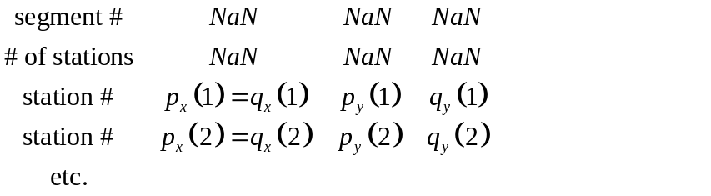
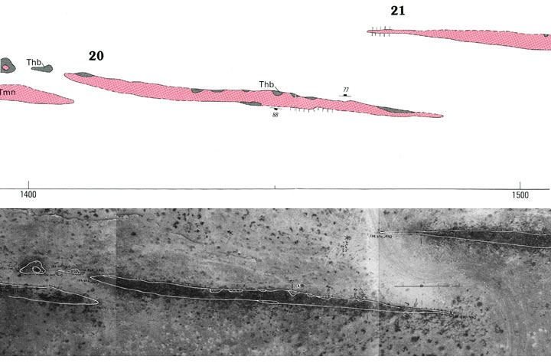
Figure 2. Details from the structural map of segments #20 and #21 of the northeastern Ship Rock dike (above) and aerial photograph (below) used as a mapping base with field notes (Delaney and Pollard, 1981). Thb and gray color represent Tertiary Heterobreccia composed of shale, sandstone, and minette; Tmn and red color represent Tertiary Minette; white color represents Mancos Shale.

2) Zoom in to check the details of your map in comparison to Figure 2 (above) and Figure 2.7 (textbook), which are taken from USGS Professional Paper 1202. Also, use the additional views of the map and original aerial photographs on the textbook website. Describe the characteristic shapes of the dike segments and contacts. Describe the geological features and structures that are found on the USGS map, but not on your map from the digitized data. In particular describe the occurrence of breccias relative to igneous rock (minette) in the dike segments.

3) The azimuth of the local x-axis for mapping the northeastern dike at Ship Rock is 056 degrees measured clockwise from north in the horizontal plane. Transform the local (x, y) axes to the UTM (Easting, Northing) axes by a rotation about the vertical z-axis. Plot and print a new map with equally-scaled local coordinate axes. Explain why the x- and y-components of position vectors p and q change under this transformation, but the position vectors themselves are unchanged.

4) Transform the origin of the local coordinates by a translation to the UTM origin for Zone M12. Plot and print a map with equally-scaled UTM grid axes. Zoom in to check the details of your map. How does your map compare to the map of the northeastern dike shown in Figure 2 of USGS Prof. Paper 1202? Comment on the relationship between map scale and the representation of geological features on a map.

5) Use the transformed data for the northeastern dike to calculate a single value for the strike of each segment and a single value for the strike of the entire dike. Explain how you made this calculation and your assumptions. Compare your result to the values in Table 2 of USGS Prof. Paper 1202. Explain what is meant by echelon segments and suggest how they might form.

6) Use the transformed data for the northeastern dike to calculate the local strike of the dike contact at each data station. Explain how you made this calculation and your assumptions. Plot and print a graph of local strike versus position from the southwest termination of the dike. Compare your graph to that in Figure 3 (below) and to your results from question 5 for each dike segment.
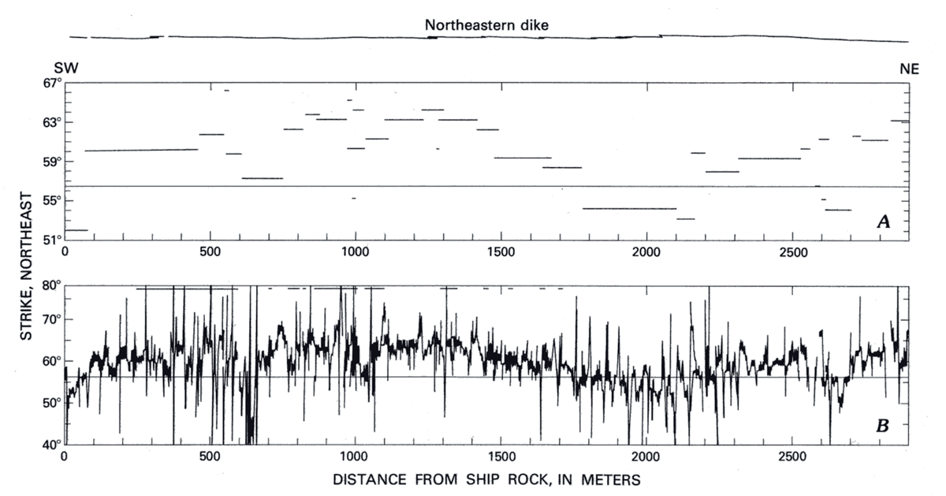
Figure 3. Strike of northeastern dike as a function of distance along the dike (Delaney and Pollard, 1981, Figure 6). Upper graph is average strike of segments. Lower graph is local strike of the dike contact.

7) The apparent thickness, t(i), of the northeastern dike at Ship Rock is defined as the distance between the two sides of the dike along a line perpendicular to the local x-axis:
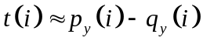
Plot and print a graph of apparent thickness versus position, x, along the entire dike. Note that the thickness goes to zero at the terminations of each dike segment and that a typical thickness near the middle of each segment is 2 to 3 m. Compare and contrast the form of the thickness distributions near terminations for segments that underlap and are essentially co-planar (e.g. #7 - #8, or #14 - #15), with segments that overlap and are arranged in echelon patterns (e.g. #15 - #16, or #20 - #21). Refer to Fig. 2.7 (textbook) for a map of these segments.

8) In some localities the thickness of the northeastern dike is significantly greater than average (2.3 m), ranging up to about 7 m. Describe the geological phenomena as shown on the USGS map (Fig. 2.7, textbook) that correlate spatially with thickness anomalies along the dike. Also, use the views of the map and original aerial photographs on the website. Compare and contrast the two different physical mechanisms that are the major contributors to dike thickness.

9) The true thickness, T(i), of the northeastern dike at Ship Rock is defined as the distance between the two sides of the dike along a line perpendicular to the local strike of the dike contact. Calculate and plot the true thickness versus position, x, along the entire dike. Explain how you chose to calculate the local strike. Print this graph. Does it matter which contact you use to determine the local strike? Compare your values t(i) and T(i), describing a few characteristic examples where the apparent thickness is a good approximation to the true thickness, and where it is not.

